**SDLC, Agile and software Testing Task**

1. Open azure DevOps.

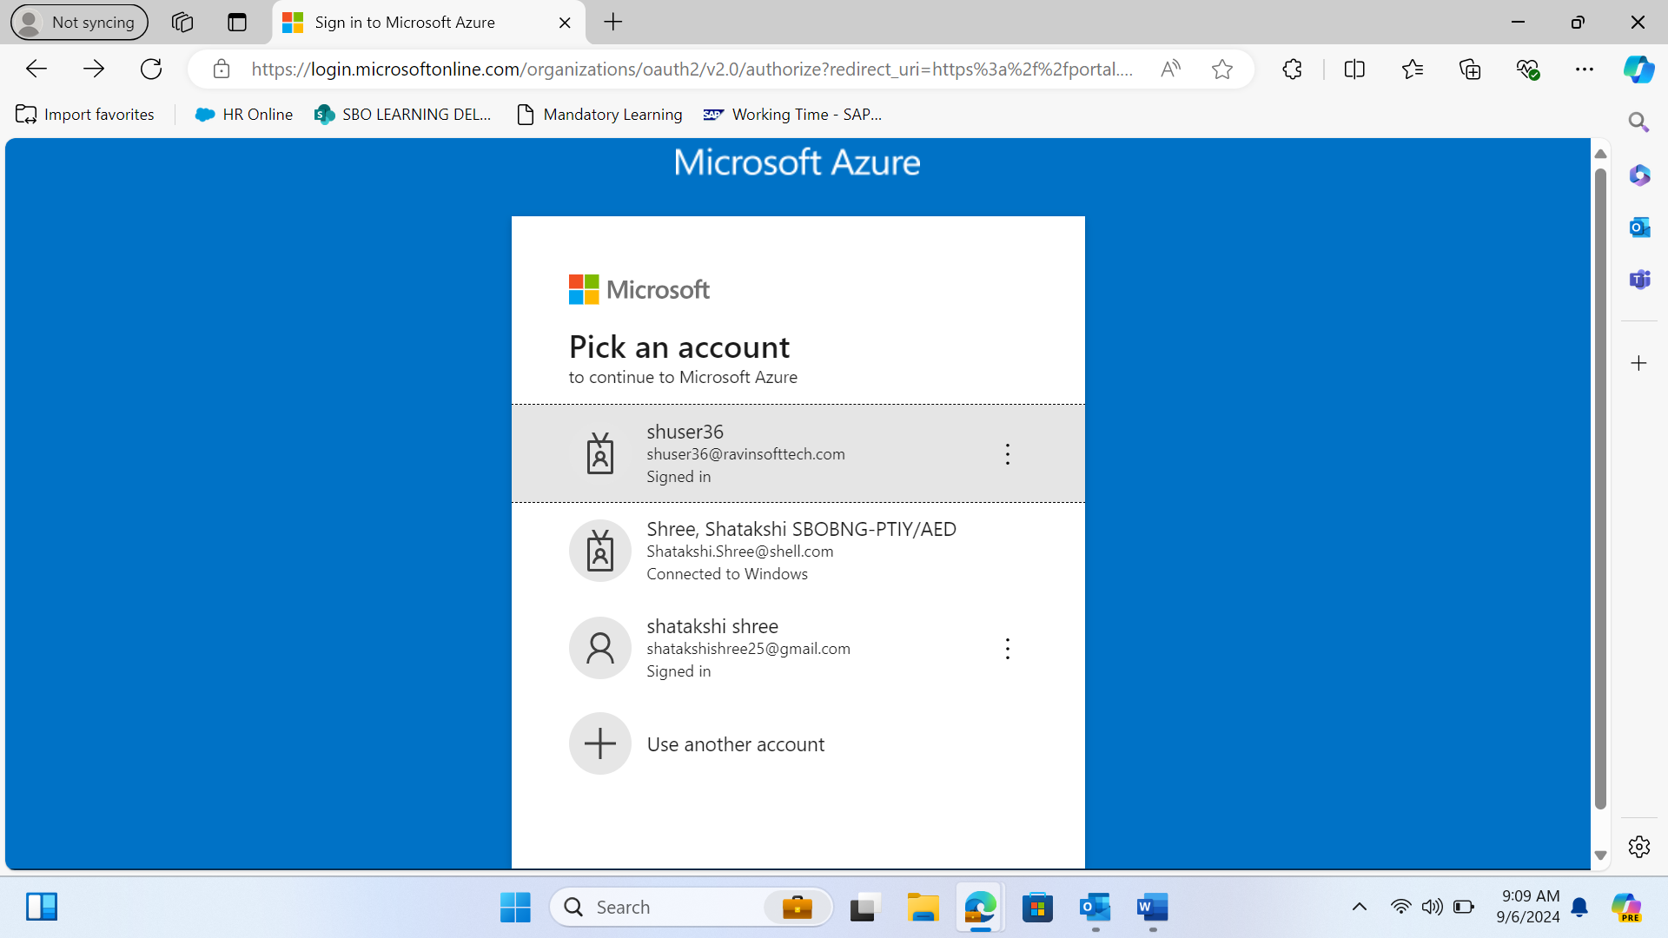

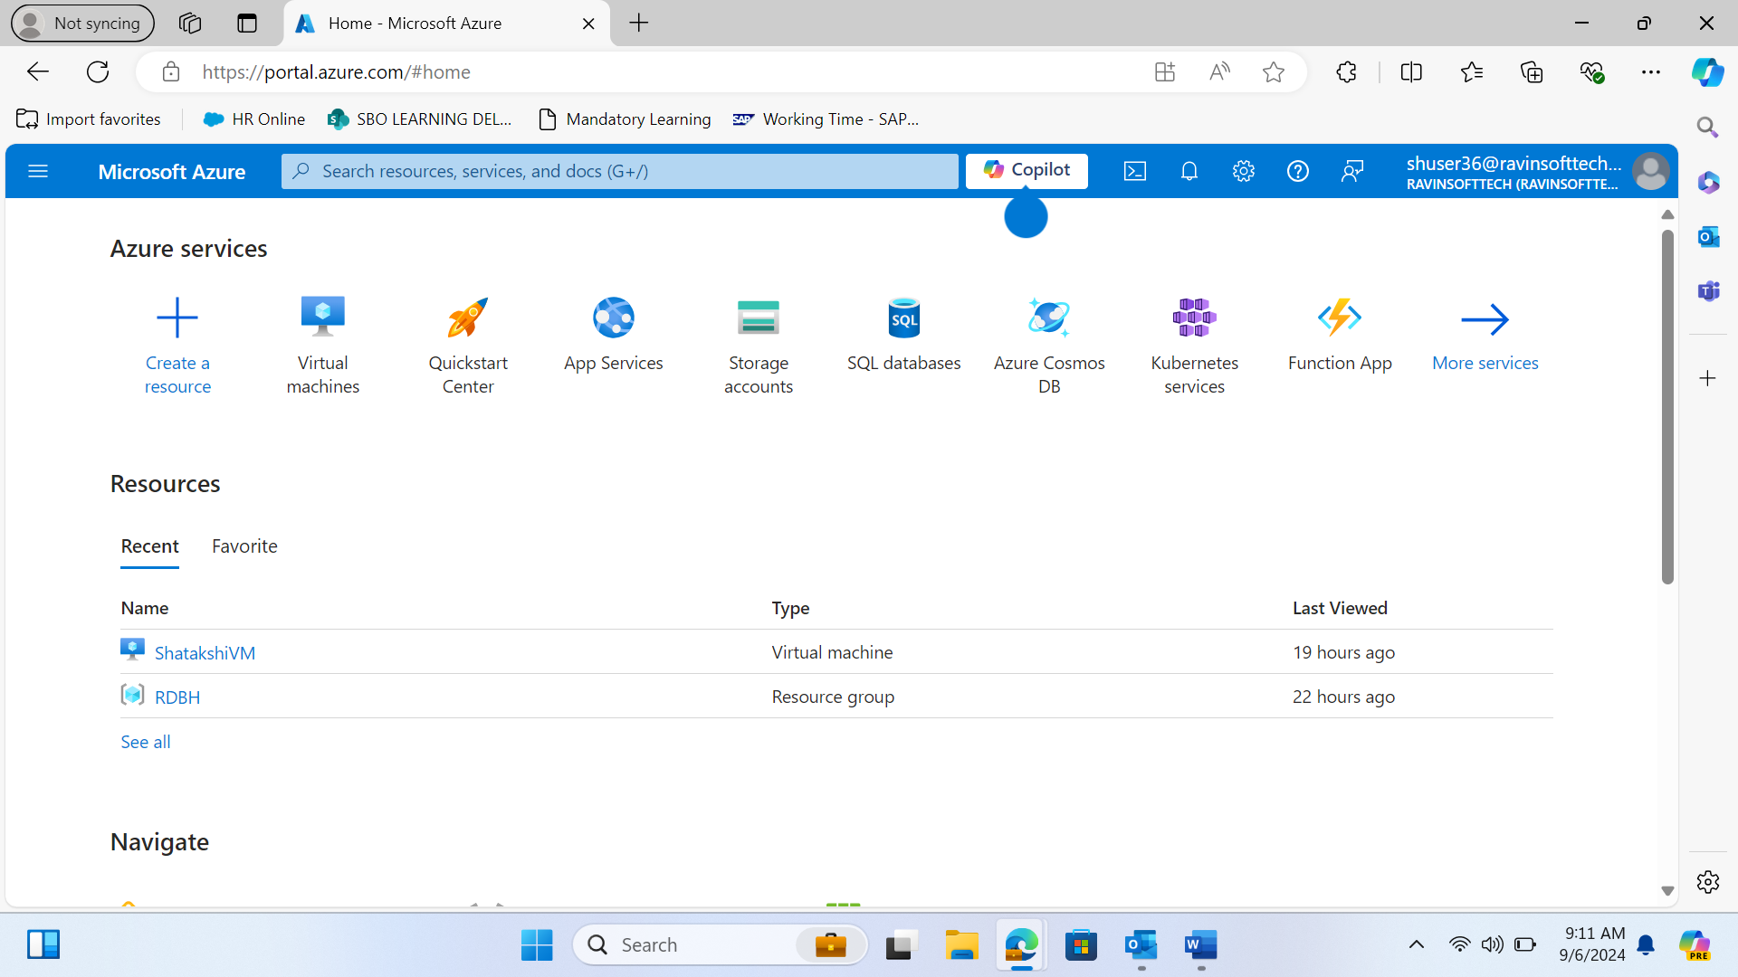

1. Create a VM

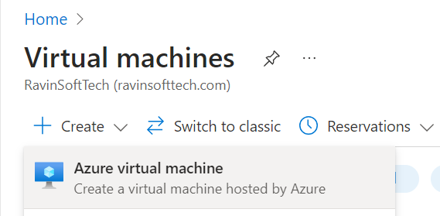

1. Fill Basics

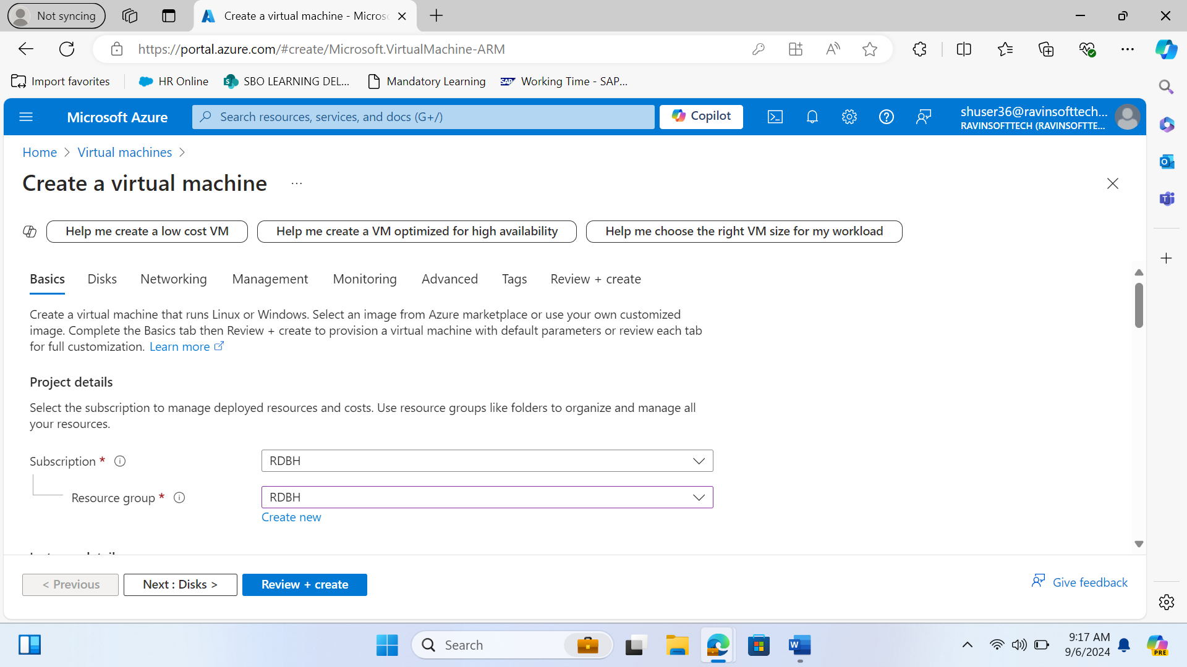

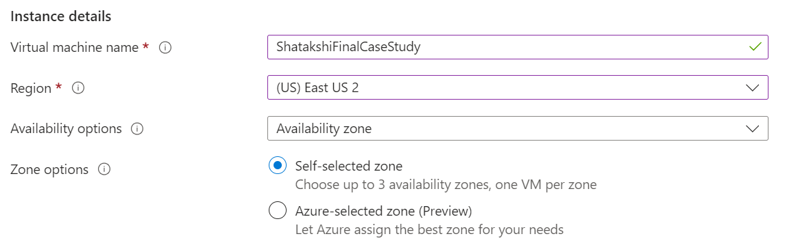

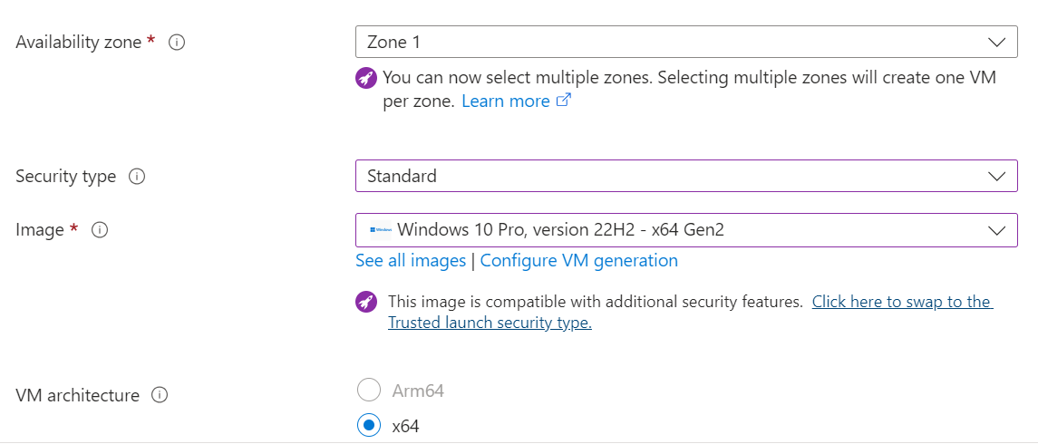

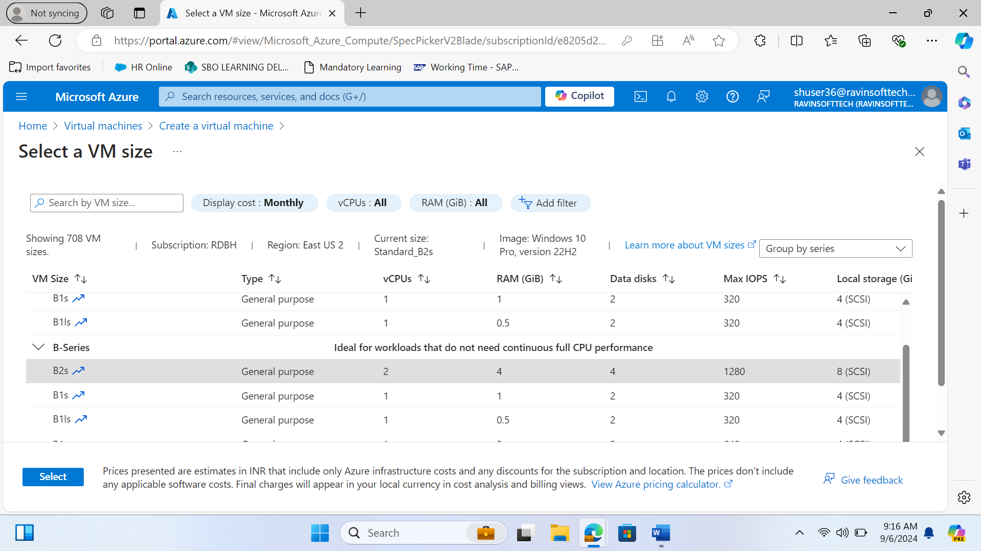

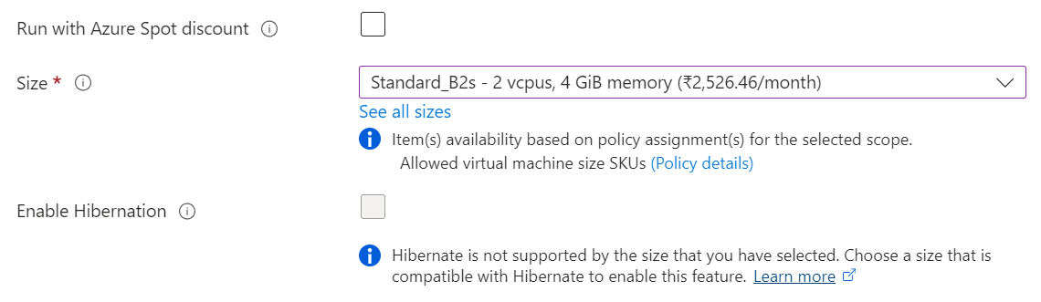

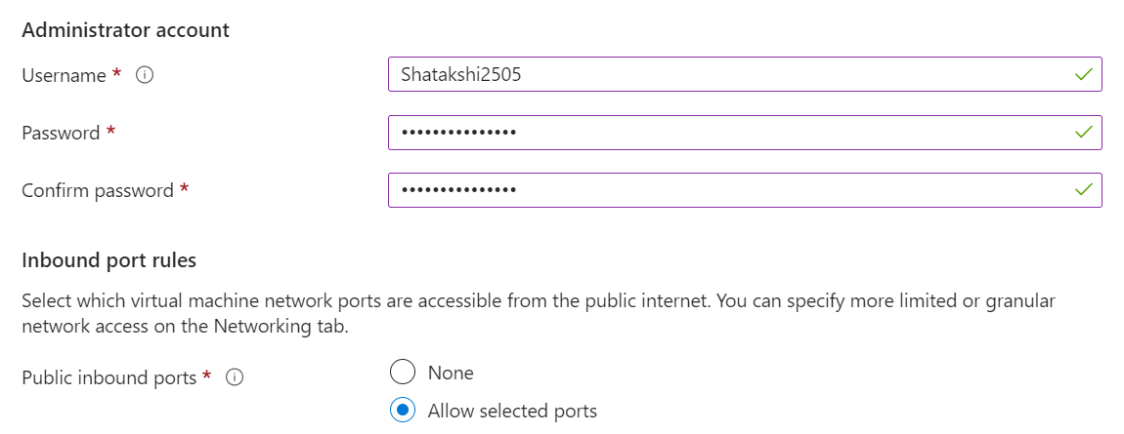

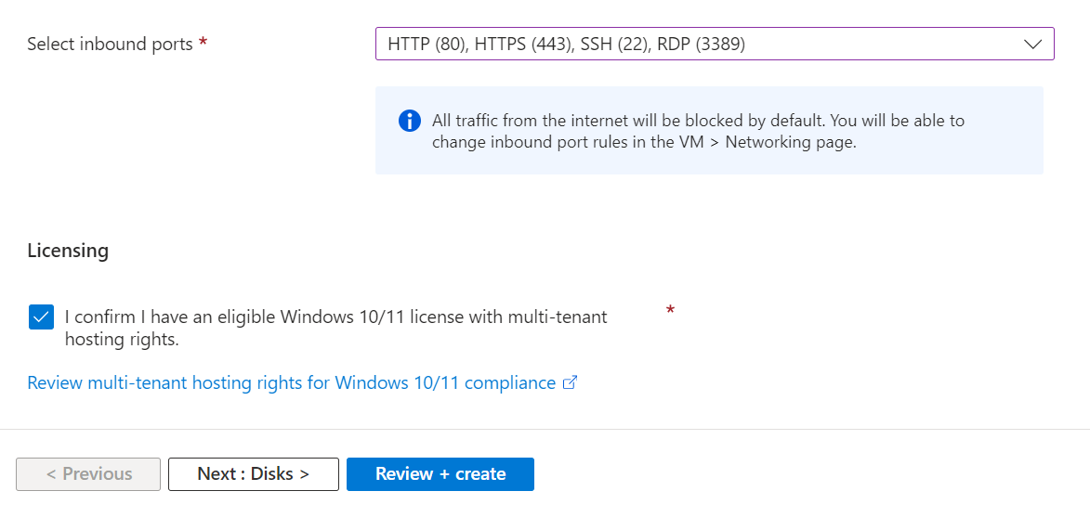

1. Fill Disks

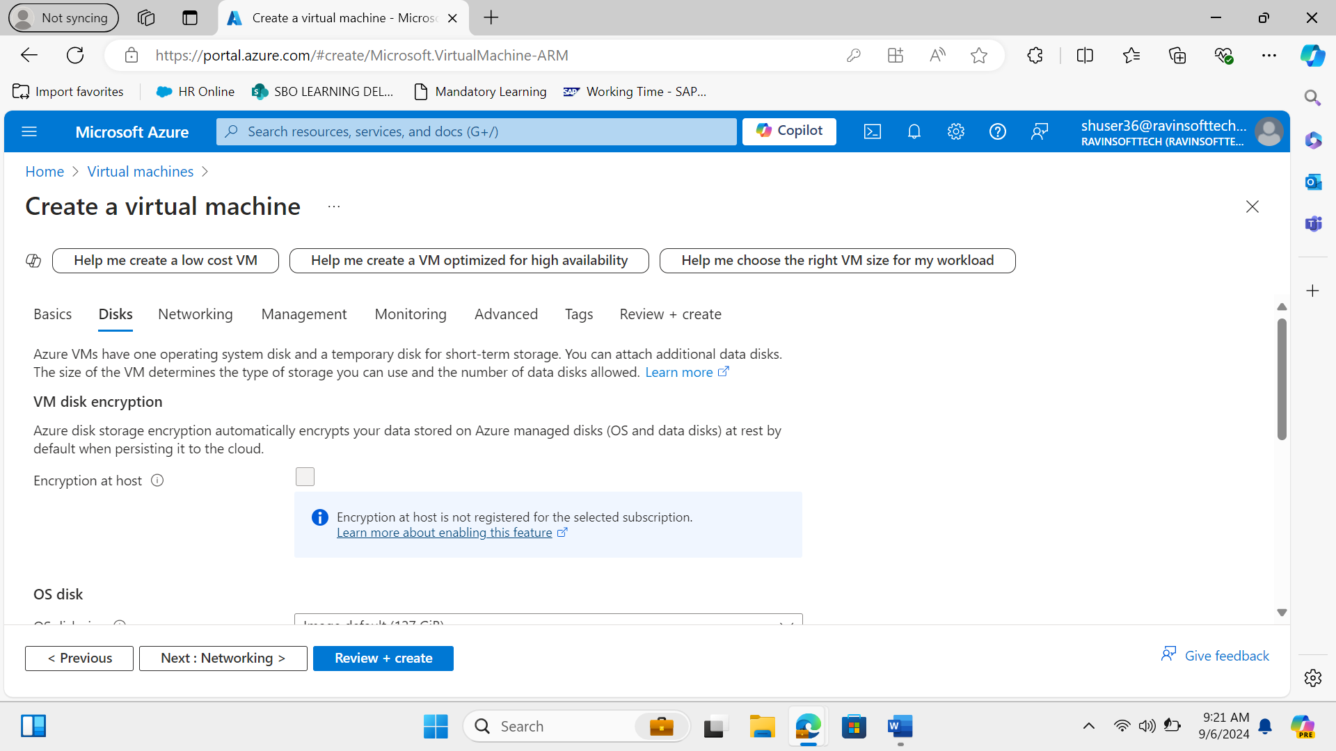

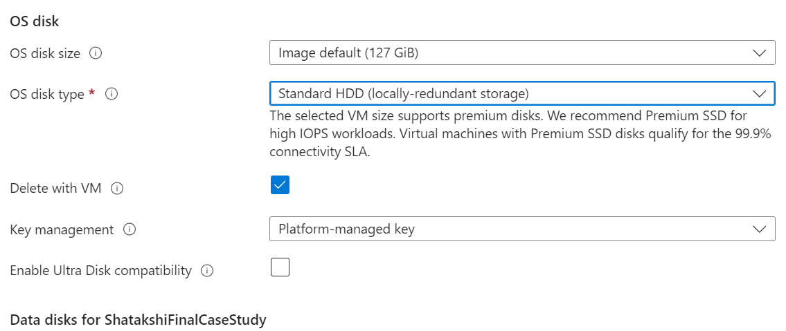

1. Fill networking

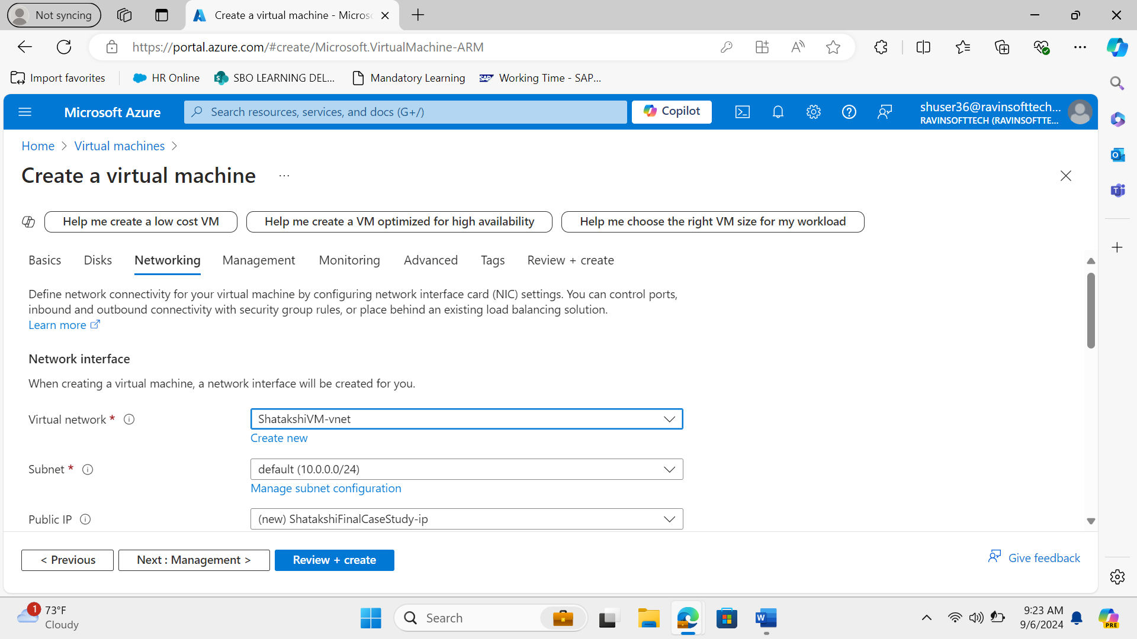

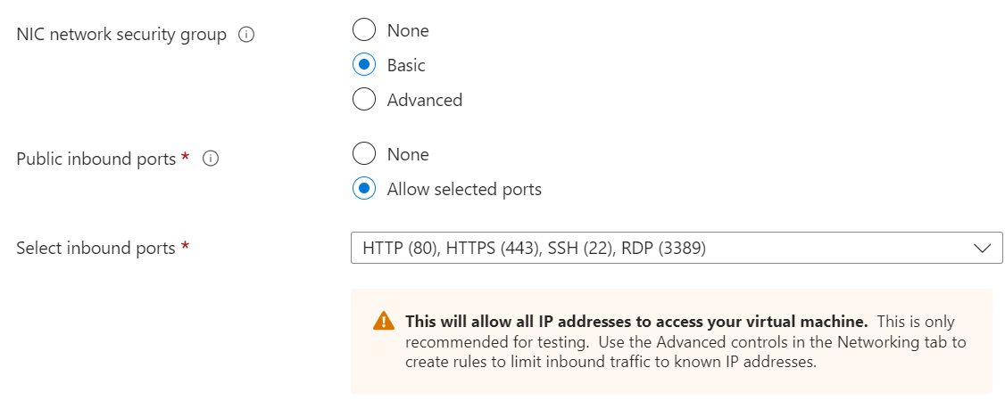

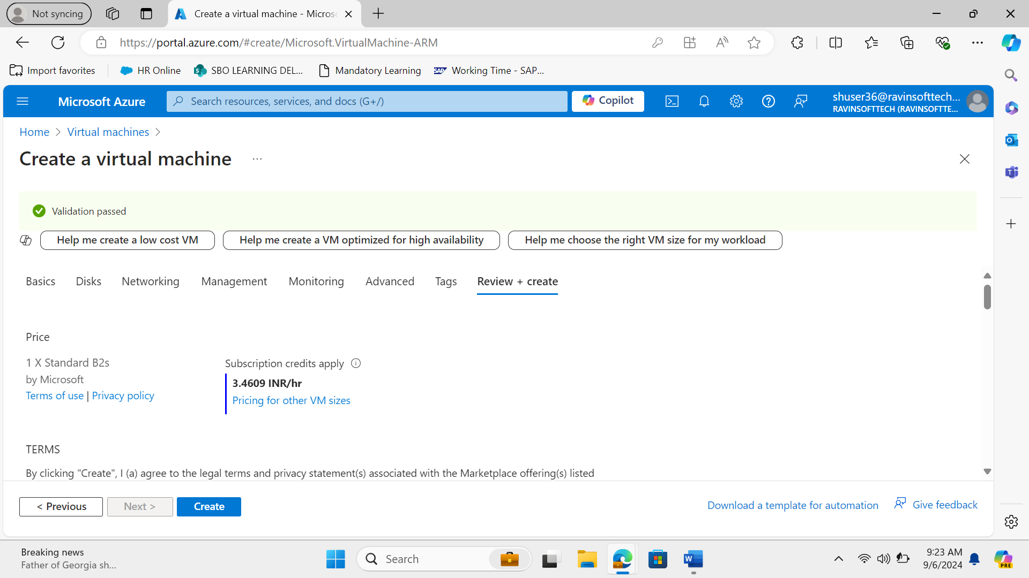

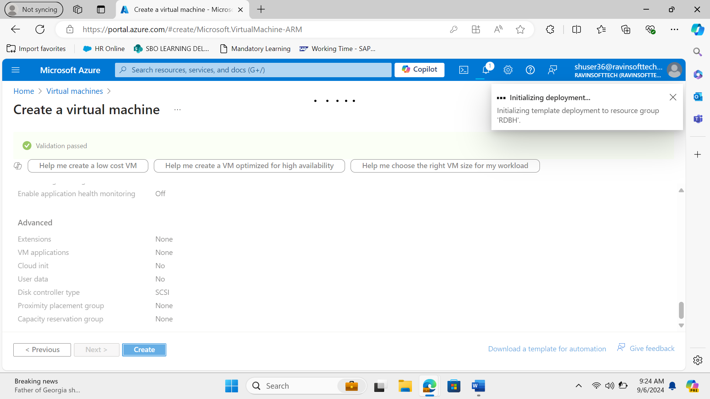

1. Deployment of VM

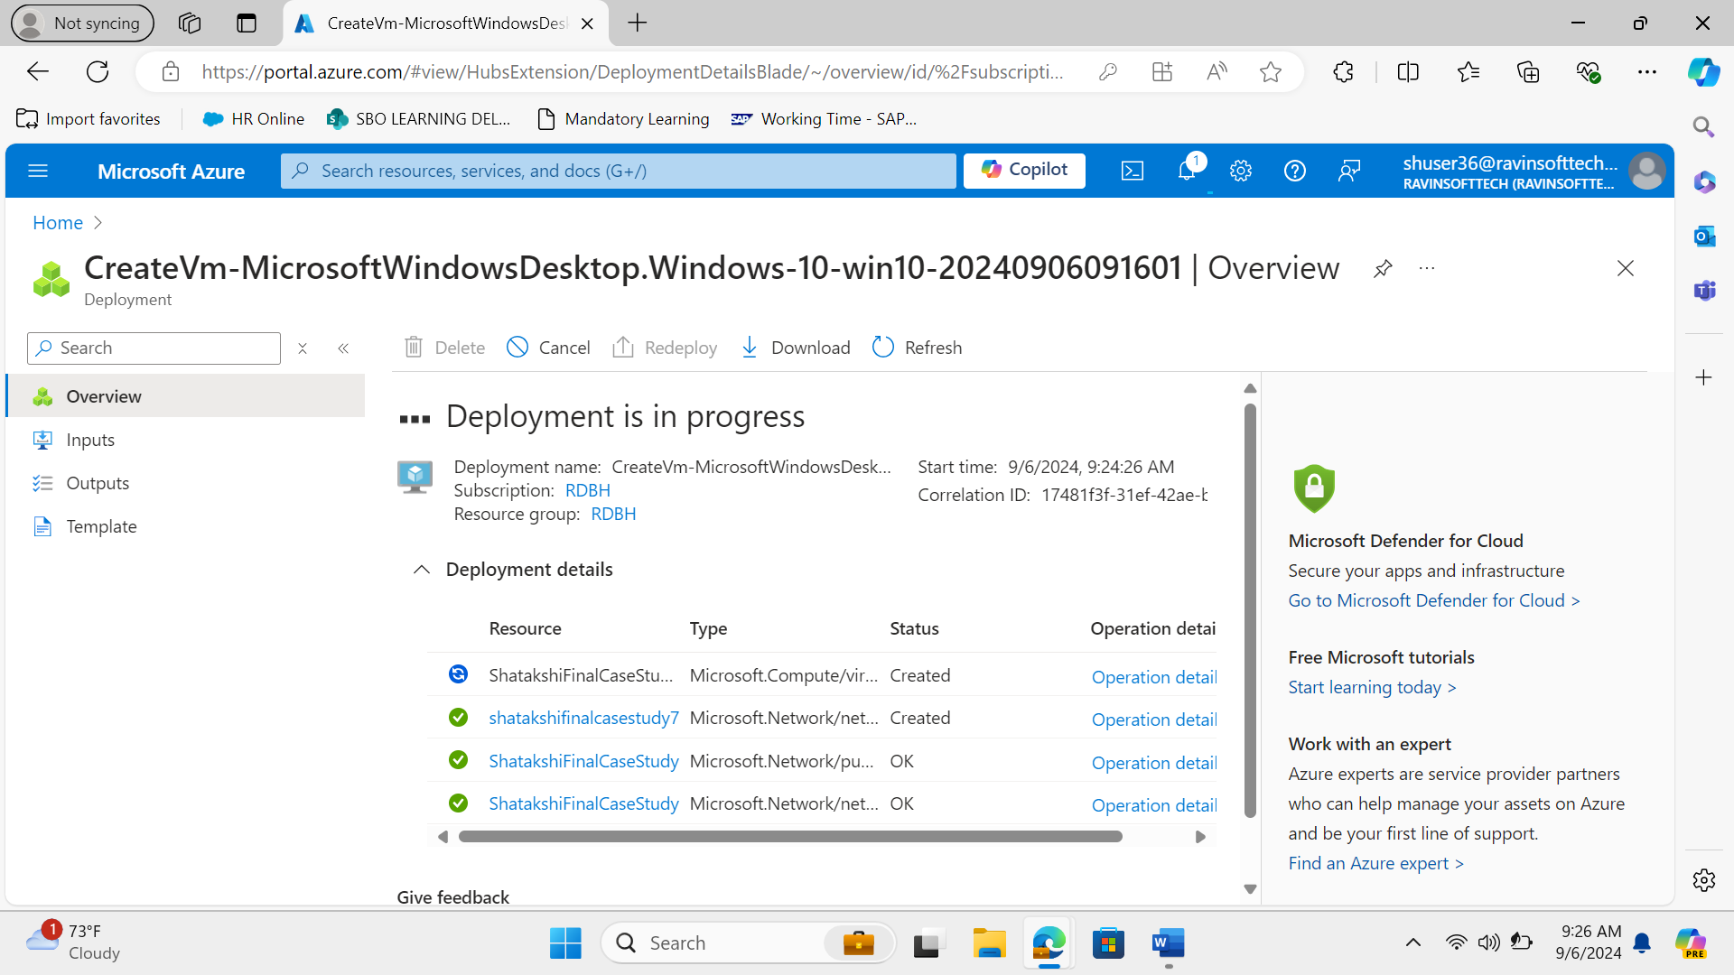

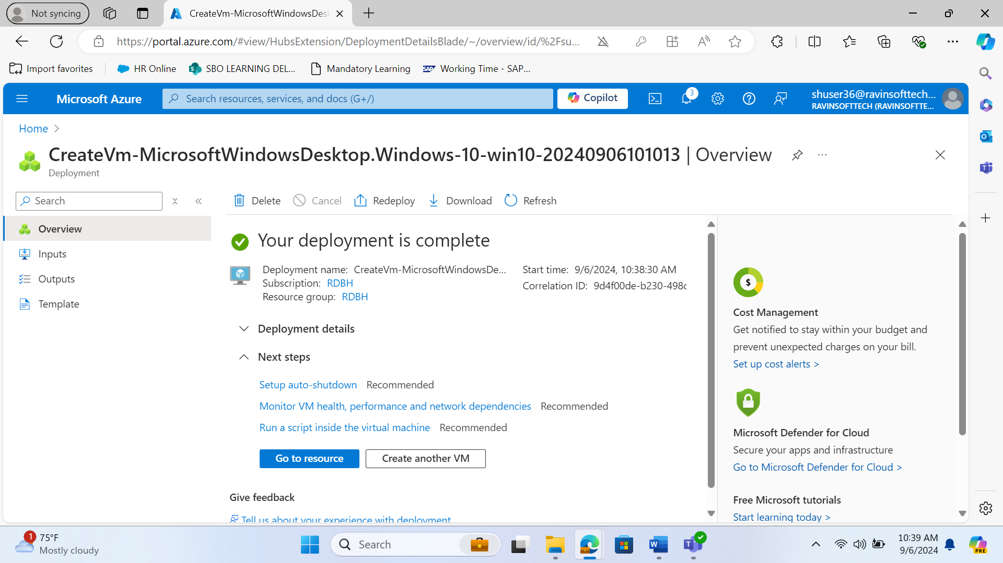

1. Connect

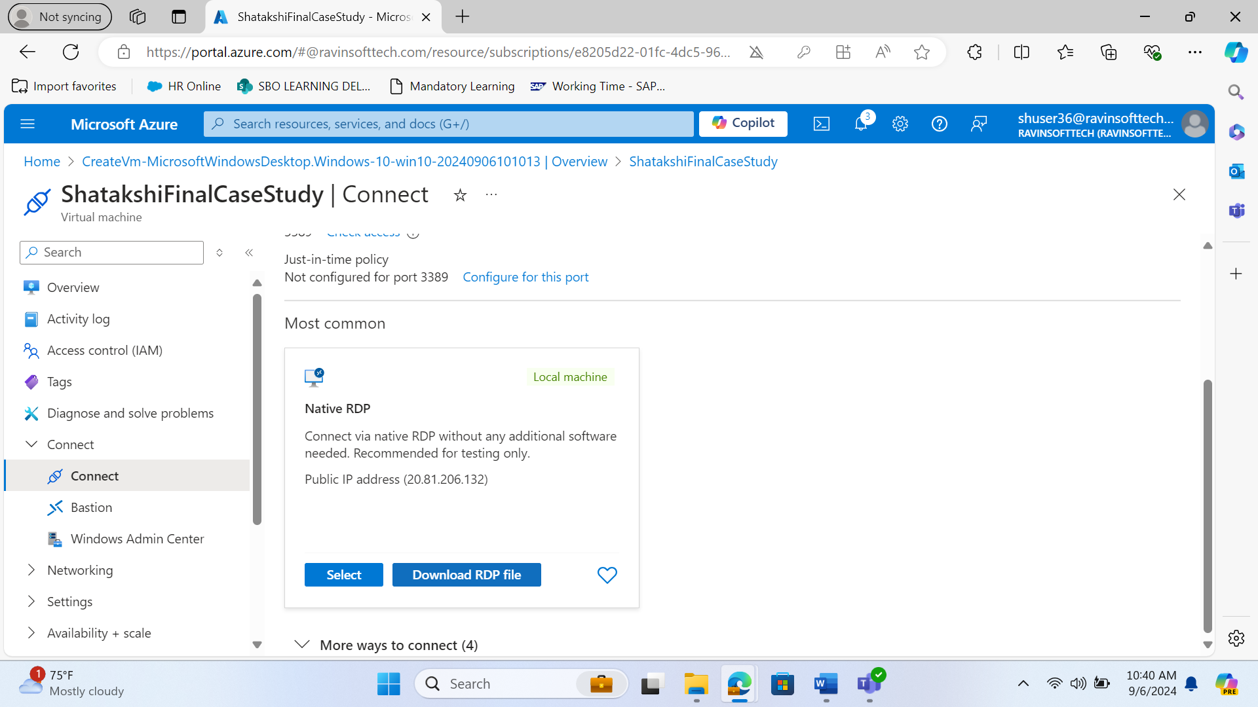

1. Download RDP file to create a VM on your own PC

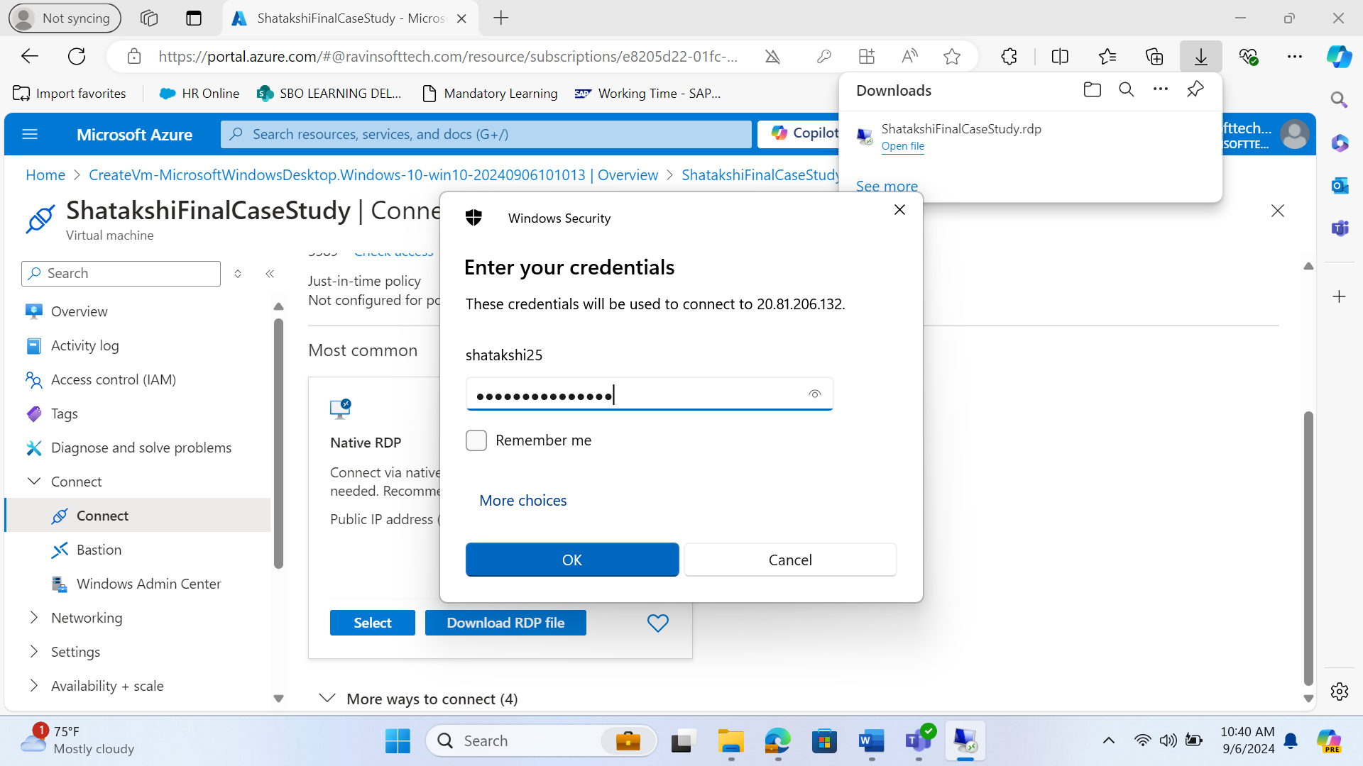

1. Creating User stories

**User stories related to the OrangeHRM website:**

**User Story-1 : As an admin, I want to add new employees to the system so that I can manage employee records**

**Acceptance Criteria:**

Navigation: The admin should be able to navigate to the “Add Employee” page from the “PIM” module.

Form Fields: The “Add Employee” form should include fields for employee details such as name, ID, department, and job title.

Form Validation: The form should validate required fields and display appropriate error messages if any required field is missing.

Save Functionality: The admin should be able to enter valid employee details and save them successfully.

Success Message: A success message should be displayed upon successfully adding a new employee.

Employee List: The newly added employee should appear in the “Employee List”.

Edit Functionality: The admin should be able to edit the details of the newly added employee and save the changes successfully.

**Test Cases:**

1. **Test Case 1**: Verify that the admin can navigate to the “Add Employee” page.
   * **Steps**: Login as admin -> Navigate to “PIM” -> Click on “Add Employee”.
   * **Expected Result**: The “Add Employee” page should be displayed.

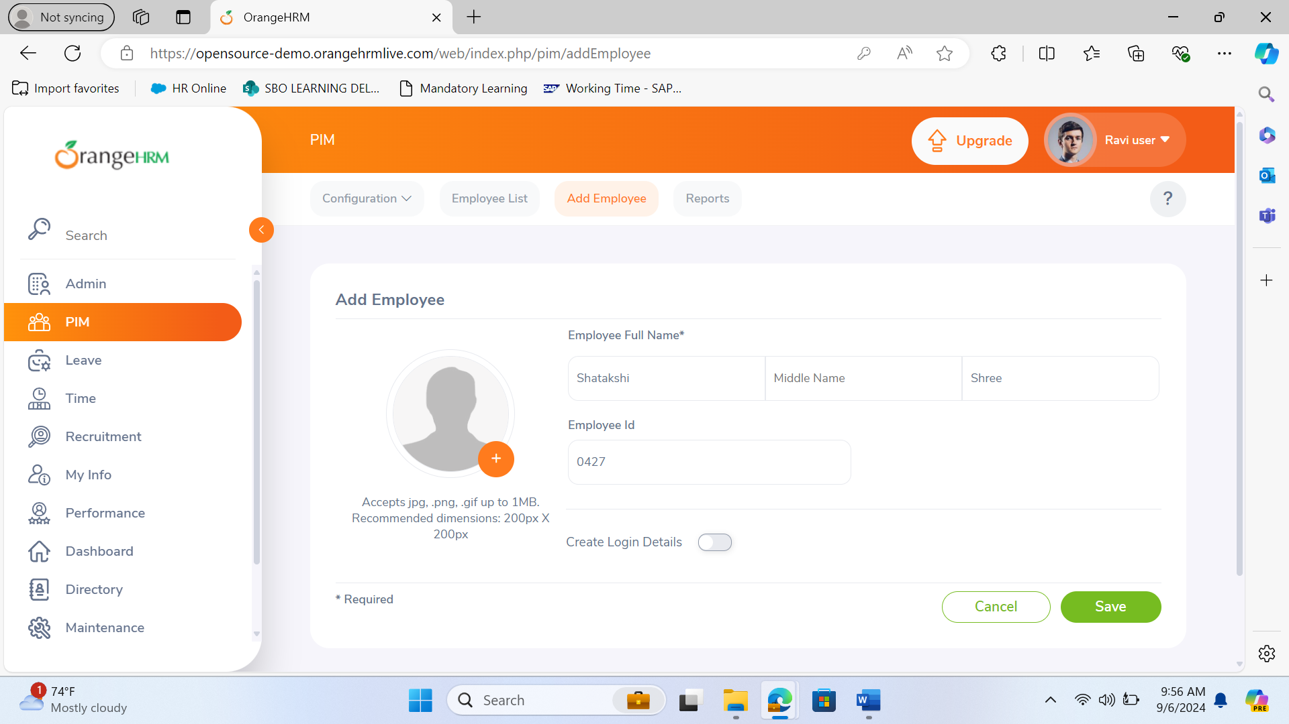

1. **Test Case 2**: Verify that the admin can enter employee details and save them.
   * **Steps**: Enter valid employee details -> Click “Save”.
   * **Expected Result**: Employee details should be saved successfully.
2. **Test Case 3**: Verify that the system displays a success message upon adding a new employee.
   * **Steps**: Enter valid employee details -> Click “Save”.
   * **Expected Result**: A success message should be displayed.

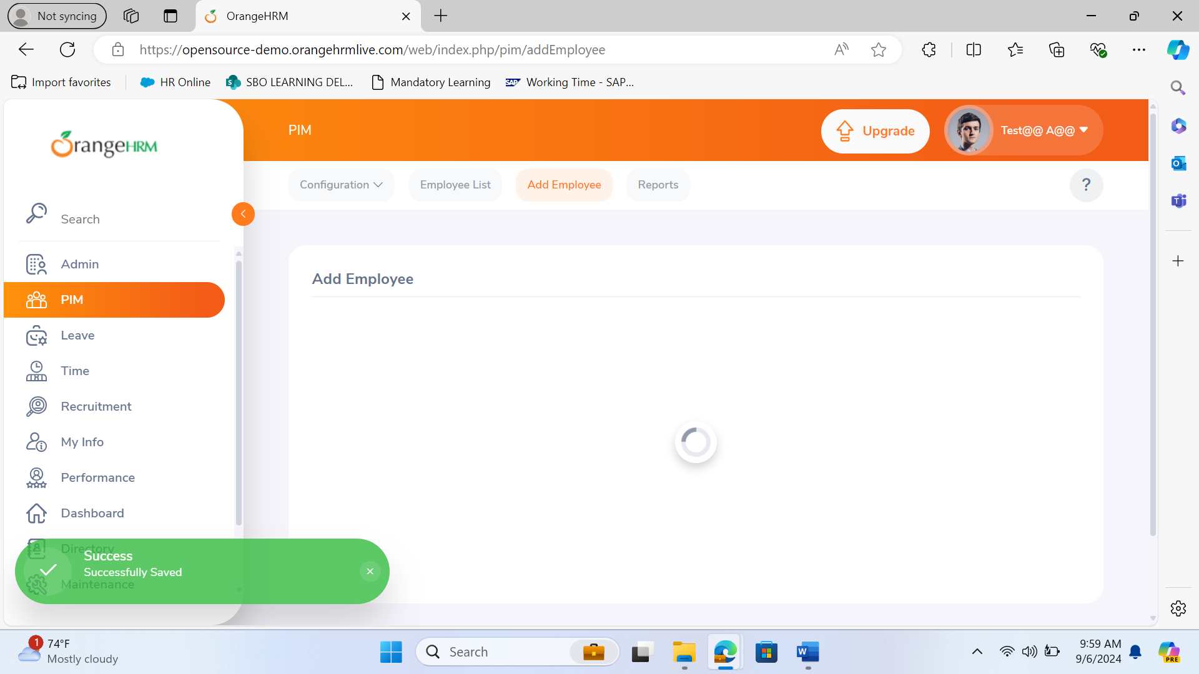

1. **Test Case 4**: Verify that the new employee appears in the employee list.
   * **Steps**: Add a new employee -> Navigate to “Employee List”.
   * **Expected Result**: The newly added employee should appear in the list.

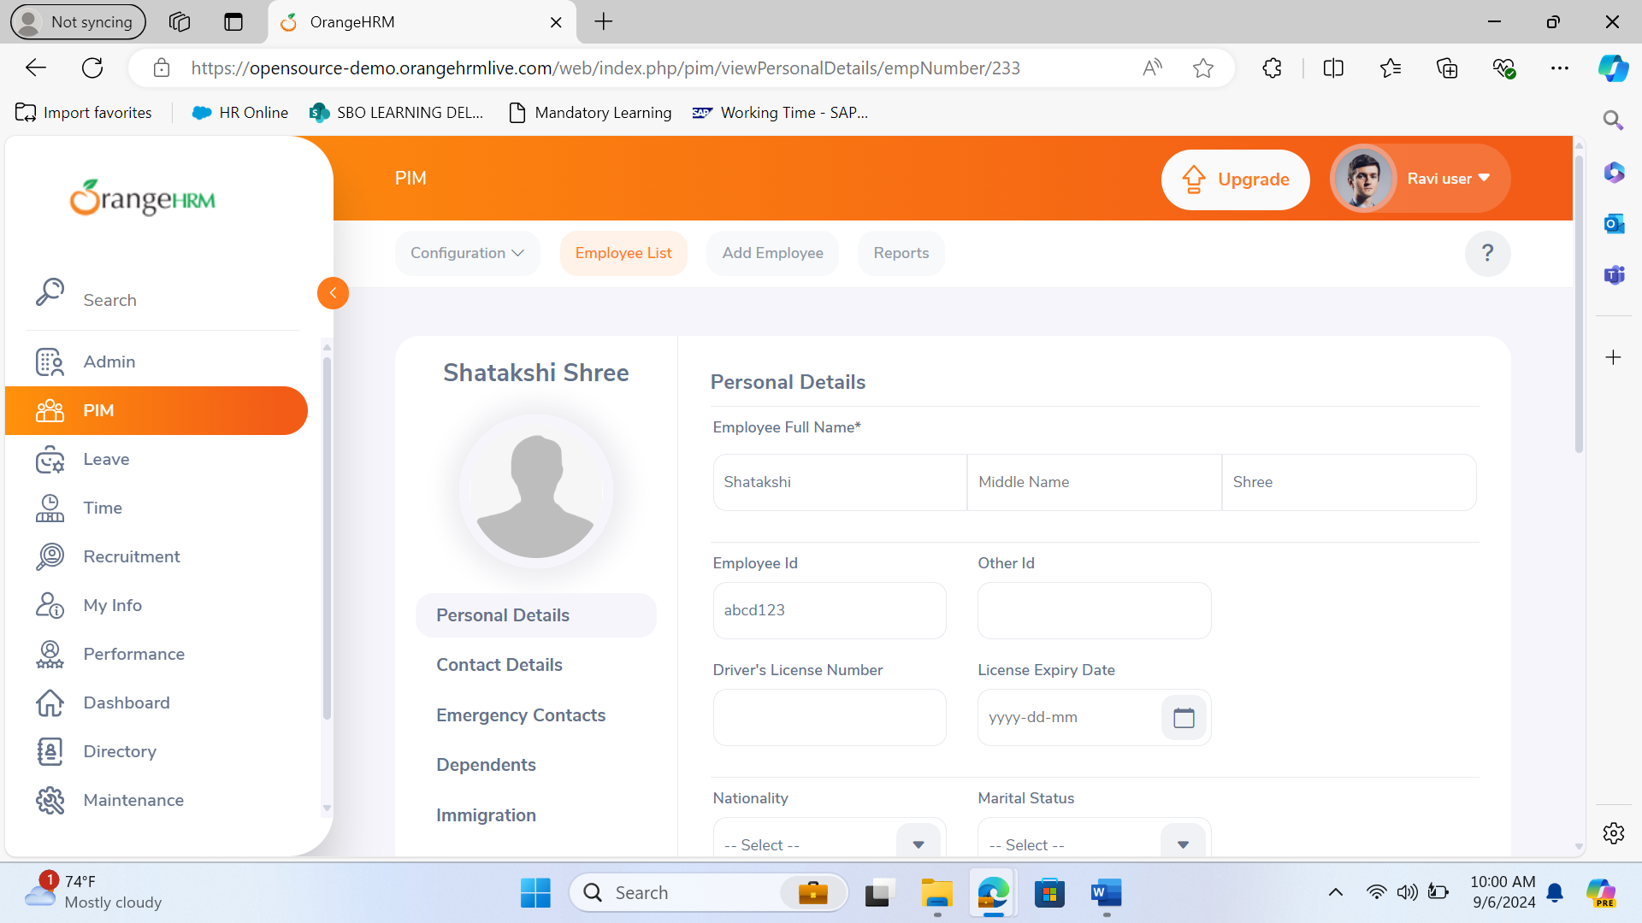

1. **Test Case 5**: Verify that the admin can edit the details of the newly added employee.
   * **Steps**: Navigate to “Employee List” -> Select the newly added employee -> Edit details -> Click “Save”.
   * **Expected Result**: The employee details should be updated successfully.

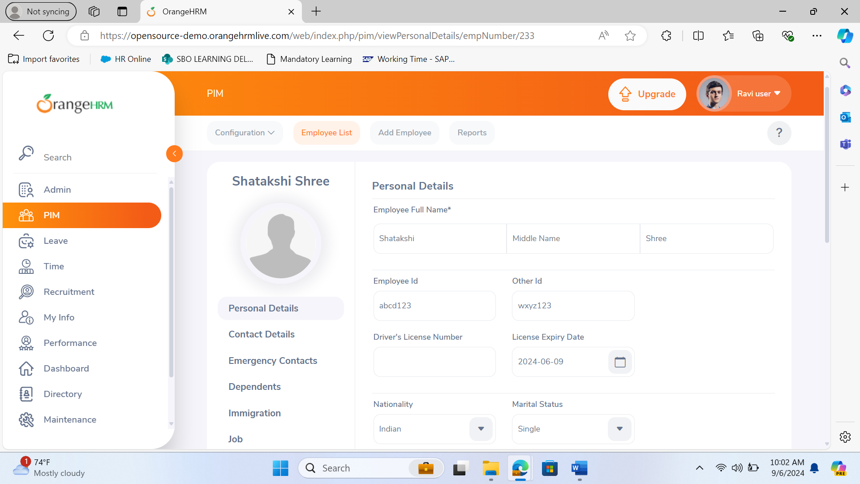

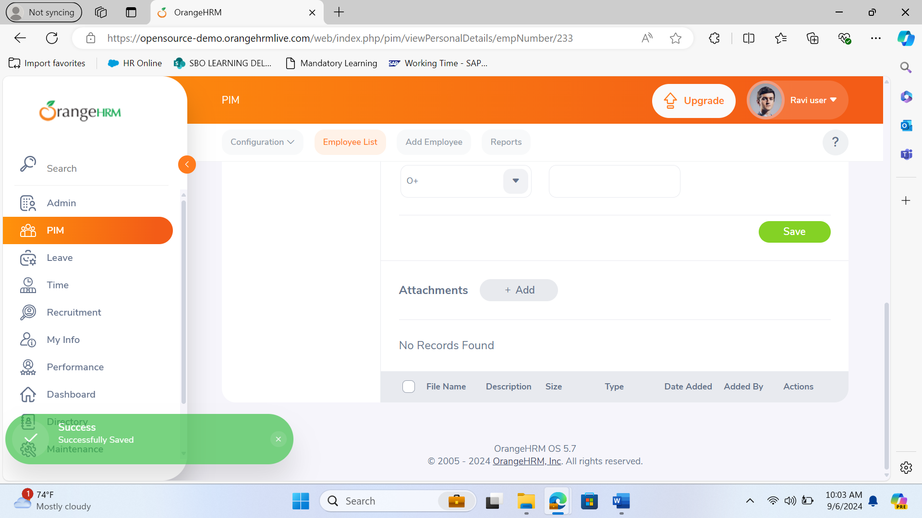

Task - Design the “Add Employee” Form

Subtasks:

Subtask 1: Create form fields for employee details (e.g., name, ID, department).

Subtask 2: Implement form validation for required fields.

Subtask 3: Design the user interface for the form.

Task - Develop Backend Logic for Adding Employees

Subtask 1: Create API endpoint for adding employees.

Subtask 2: Implement database integration to store employee details.

Subtask 3: Write server-side validation logic.

Task - Test the “Add Employee” Functionality

Subtask 1: Write unit tests for the API endpoint.

Subtask 2: Perform integration testing with the frontend.

Subtask 3: Conduct user acceptance testing (UAT).

Task - Deploy and Monitor

Subtask 1: Deploy the new feature to the staging environment.

Subtask 2: Monitor logs for any errors or issues.

Subtask 3: Deploy to production after successful testing.

**User Story 2: As an employee, I want to apply for leave so that I can manage my leave balance.**

Acceptance Criteria:

Navigation: The employee should be able to navigate to the “Apply Leave” page from the “Leave” module.

Form Fields: The “Apply Leave” form should include fields for leave type, start date, and end date.

Form Validation: The form should validate the selected leave type and dates, and display appropriate error messages if any required field is missing.

Submit Functionality: The employee should be able to select a leave type and dates, and submit the leave application successfully.

Success Message: A success message should be displayed upon successfully submitting a leave application.

Leave Balance Update: The leave balance should be updated accordingly after the leave application is submitted.

**Test Cases:**

1. **Test Case 1**: Verify that the employee can navigate to the “Apply Leave” page.
   * **Steps**: Login as employee -> Navigate to “Leave” -> Click on “Apply”.
   * **Expected Result**: The “Apply Leave” page should be displayed.

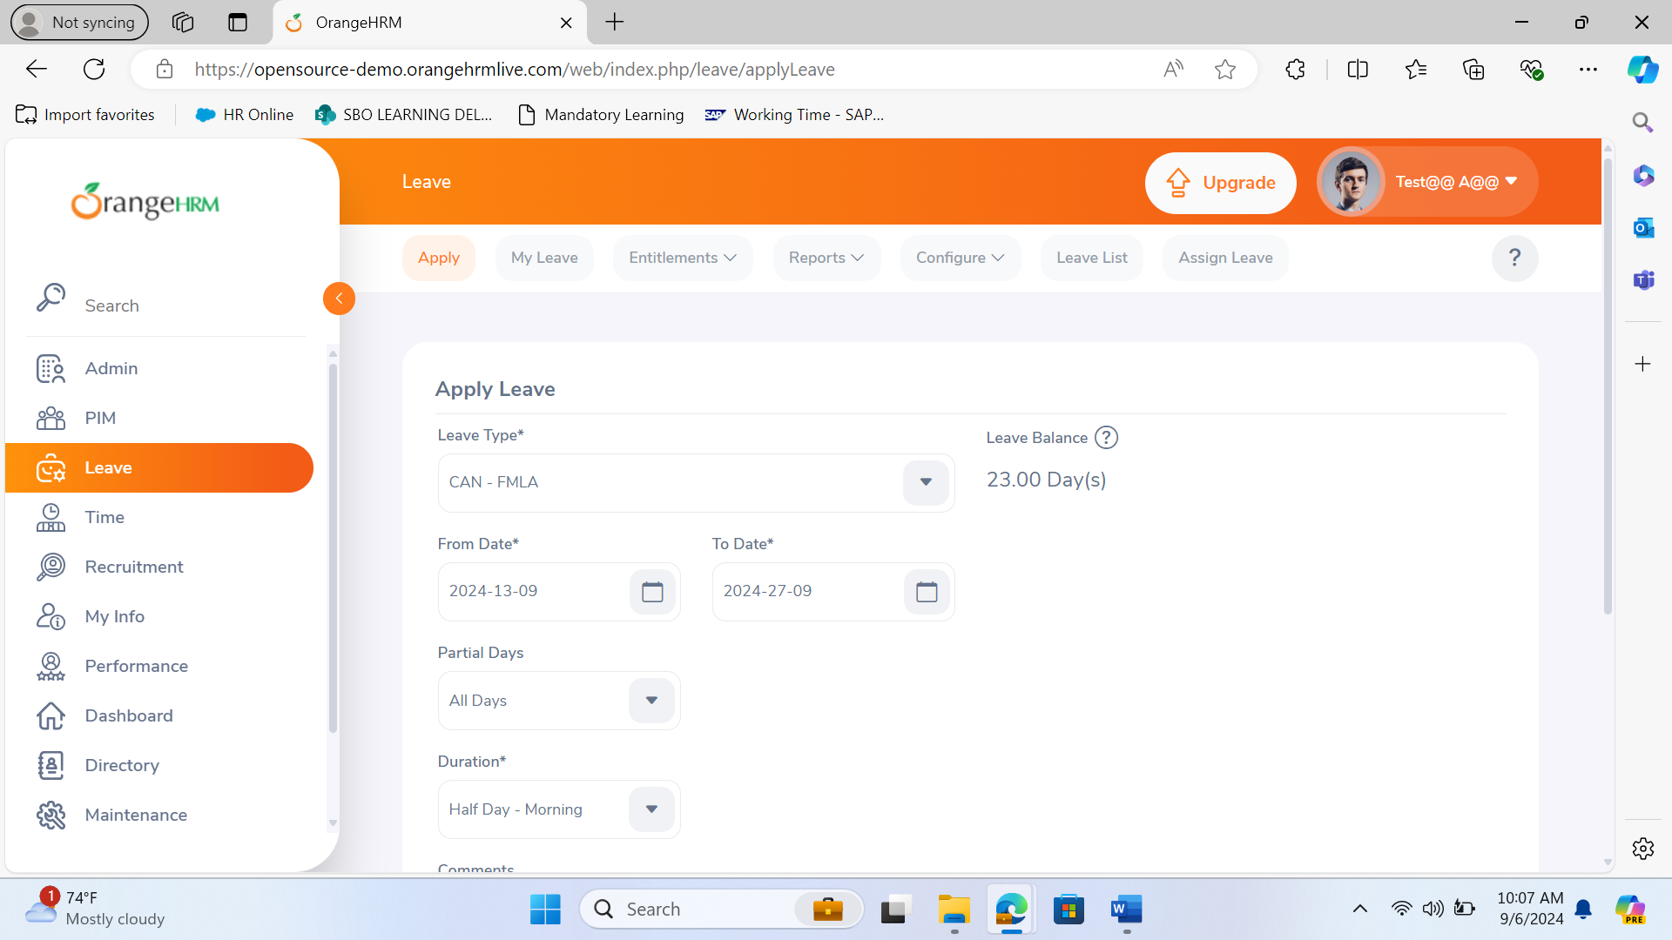

1. **Test Case 2**: Verify that the employee can select leave type and dates.
   * **Steps**: Select leave type -> Select start and end dates.
   * **Expected Result**: Leave type and dates should be selectable.
2. **Test Case 3**: Verify that the employee can submit a leave application.
   * **Steps**: Select leave type and dates -> Click “Apply”.
   * **Expected Result**: Leave application should be submitted successfully.
3. **Test Case 4**: Verify that the system displays a success message upon leave application submission.
   * **Steps**: Select leave type and dates -> Click “Apply”.
   * **Expected Result**: A success message should be displayed.

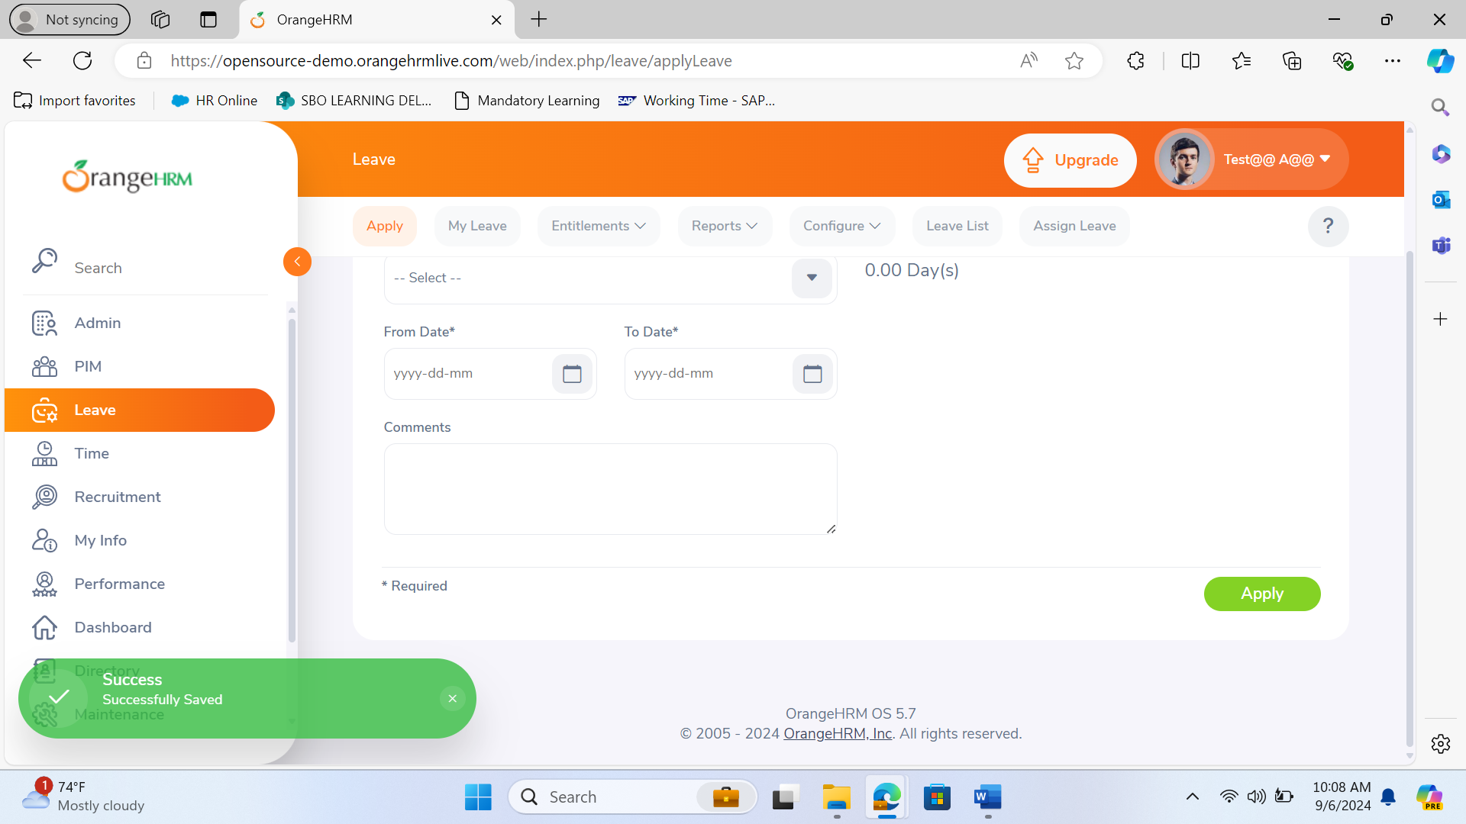

1. **Test Case 5**: Verify that the leave balance is updated after leave application submission.
   * **Steps**: Submit a leave application -> Navigate to “My Leave” -> Check leave balance.
   * **Expected Result**: Leave balance should be updated accordingly.

Task - Design the “Apply Leave” Form

Subtask 1: Create form fields for leave type and dates.

Subtask 2: Implement form validation for date selection.

Subtask 3: Design the user interface for the form.

Task - Develop Backend Logic for Leave Application

Subtask 1: Create API endpoint for submitting leave applications.

Subtask 2: Implement database integration to store leave applications.

Subtask 3: Write server-side validation logic.

Task - Test the “Apply Leave” Functionality

Subtask 1: Write unit tests for the API endpoint.

Subtask 2: Perform integration testing with the frontend.

Subtask 3: Conduct user acceptance testing (UAT).

Task - Deploy and Monitor

Subtask 1: Deploy the new feature to the staging environment.

Subtask 2: Monitor logs for any errors or issues.

Subtask 3: Deploy to production after successful testing.

**User Story 3: As an admin, I want to generate payroll reports so that I can process employee salaries.**

Acceptance Criteria:

Navigation: The admin should be able to navigate to the “Payroll Reports” page from the “Payroll” module.

Report Selection: The admin should be able to select the report type and date range for the payroll report.

Form Validation: The form should validate the selected report type and date range, and display appropriate error messages if any required field is missing.

Generate Report: The admin should be able to generate the payroll report successfully.

Success Message: A success message should be displayed upon successfully generating the payroll report.

Report Accuracy: The generated payroll report should contain accurate payroll data for the selected date range.

**Test Cases:**

1. **Test Case 1**: Verify that the admin can navigate to the “Payroll Reports” page.
   * **Steps**: Login as admin -> Navigate to “Payroll” -> Click on “Reports”.
   * **Expected Result**: The “Payroll Reports” page should be displayed.
2. **Test Case 2**: Verify that the admin can select the report type and date range.
   * **Steps**: Select report type -> Select start and end dates.
   * **Expected Result**: Report type and date range should be selectable.
3. **Test Case 3**: Verify that the admin can generate a payroll report.
   * **Steps**: Select report type and date range -> Click “Generate”.
   * **Expected Result**: Payroll report should be generated successfully.
4. **Test Case 4**: Verify that the system displays a success message upon report generation.
   * **Steps**: Select report type and date range -> Click “Generate”.
   * **Expected Result**: A success message should be displayed.
5. **Test Case 5**: Verify that the generated report contains accurate payroll data.
   * **Steps**: Generate a payroll report -> Review the report.
   * **Expected Result**: The report should contain accurate payroll data.

Task - Design the “Payroll Reports” Page

Subtask 1: Create UI components for report type and date range selection.

Subtask 2: Design the user interface for the reports page.

Subtask 3: Implement form validation for date range selection.

Task - Develop Backend Logic for Report Generation

Subtask 1: Create API endpoint for generating payroll reports.

Subtask 2: Implement database queries to fetch payroll data.

Subtask 3: Write server-side logic for report generation.

Task - Test the “Payroll Reports” Functionality

Subtask 1: Write unit tests for the API endpoint.

Subtask 2: Perform integration testing with the frontend.

Subtask 3: Conduct user acceptance testing (UAT).

Task - Deploy and Monitor

Subtask 1: Deploy the new feature to the staging environment.

Subtask 2: Monitor logs for any errors or issues.

Subtask 3: Deploy to production after successful testing.

**User Story 4: As an employee, I want to update my personal information so that my records are accurate.**

Acceptance Criteria:

Navigation: The employee should be able to navigate to the “Personal Information” page from the “My Info” module.

Form Fields: The “Personal Information” form should include fields for personal details such as name, address, and contact information.

Form Validation: The form should validate required fields and display appropriate error messages if any required field is missing.

Save Functionality: The employee should be able to edit personal details and save them successfully.

Success Message: A success message should be displayed upon successfully saving personal details.

Data Persistence: The updated personal details should be saved correctly and persist after refreshing the page.

Profile Picture Upload: The employee should be able to upload a profile picture successfully.

**Test Cases:**

1. **Test Case 1**: Verify that the employee can navigate to the “Personal Information” page.
   * **Steps**: Login as employee -> Navigate to “My Info” -> Click on “Personal Details”.
   * **Expected Result**: The “Personal Information” page should be displayed.
2. **Test Case 2**: Verify that the employee can edit personal details.
   * **Steps**: Edit personal details -> Click “Save”.
   * **Expected Result**: Personal details should be editable.
3. **Test Case 3**: Verify that the system displays a success message upon saving personal details.
   * **Steps**: Edit personal details -> Click “Save”.
   * **Expected Result**: A success message should be displayed.
4. **Test Case 4**: Verify that the updated personal details are saved correctly.
   * **Steps**: Edit personal details -> Click “Save” -> Refresh the page.
   * **Expected Result**: The updated personal details should be saved correctly.
5. **Test Case 5**: Verify that the employee can upload a profile picture.
   * **Steps**: Navigate to “Personal Information” -> Click “Upload Picture” -> Select a picture -> Click “Save”.
   * **Expected Result**: The profile picture should be uploaded successfully.

Task - Design the “Personal Information” Page

Subtask 1: Create form fields for personal details (e.g., name, address, contact info).

Subtask 2: Implement form validation for required fields.

Subtask 3: Design the user interface for the form.

Task - Develop Backend Logic for Updating Personal Information

Subtask 1: Create API endpoint for updating personal information.

Subtask 2: Implement database integration to update employee records.

Subtask 3: Write server-side validation logic.

Task - Test the “Personal Information” Functionality

Subtask 1: Write unit tests for the API endpoint.

Subtask 2: Perform integration testing with the frontend.

Subtask 3: Conduct user acceptance testing (UAT).

Task - Deploy and Monitor

Subtask 1: Deploy the new feature to the staging environment.

Subtask 2: Monitor logs for any errors or issues.

Subtask 3: Deploy to production after successful testing.

**User Story 5: As an admin, I want to assign roles and permissions so that I can control access to different modules.**

Acceptance Criteria:

Navigation: The admin should be able to navigate to the “User Management” page from the “Admin” module.

Add User: The admin should be able to add a new user by entering user details and saving them successfully.

Assign Roles: The admin should be able to assign roles to a user and save the changes successfully.

Set Permissions: The admin should be able to set permissions for a role and save the changes successfully.

Role Enforcement: The assigned roles and permissions should be enforced, granting or denying access to different modules based on the assigned roles.

**Test Cases:**

1. **Test Case 1**: Verify that the admin can navigate to the “User Management” page.
   * **Steps**: Login as admin -> Navigate to “Admin” -> Click on “User Management”.
   * **Expected Result**: The “User Management” page should be displayed.
2. **Test Case 2**: Verify that the admin can add a new user.
   * **Steps**: Click “Add User” -> Enter user details -> Click “Save”.
   * **Expected Result**: The new user should be added successfully.
3. **Test Case 3**: Verify that the admin can assign roles to a user.
   * **Steps**: Select a user -> Click “Edit” -> Assign roles -> Click “Save”.
   * **Expected Result**: Roles should be assigned to the user successfully.
4. **Test Case 4**: Verify that the admin can set permissions for a role.
   * **Steps**: Navigate to “Roles” -> Select a role -> Set permissions -> Click “Save”.
   * **Expected Result**: Permissions should be set for the role successfully.
5. **Test Case 5**: Verify that the assigned roles and permissions are enforced.
   * **Steps**: Login as the user with assigned roles -> Attempt to access different modules.
   * **Expected Result**: Access should be granted or denied based on the assigned roles and permissions.

Tasks-Design the “User Management” Page

Subtask 1: Create UI components for adding users and assigning roles.

Subtask 2: Design the user interface for the user management page.

Subtask 3: Implement form validation for user details.

Task - Develop Backend Logic for User Management

Subtask 1: Create API endpoint for adding users and assigning roles.

Subtask 2: Implement database integration to store user roles and permissions.

Subtask 3: Write server-side logic for role-based access control.

Task - Test the “User Management” Functionality

Subtask 1: Write unit tests for the API endpoint.

Subtask 2: Perform integration testing with the frontend.

Subtask 3: Conduct user acceptance testing (UAT).

Task - Deploy and Monitor

Subtask 1: Deploy the new feature to the staging environment.

Subtask 2: Monitor logs for any errors or issues.

Subtask 3: Deploy to production after successful testing.

1. Open Azure DevOps
2. Change project process to agile

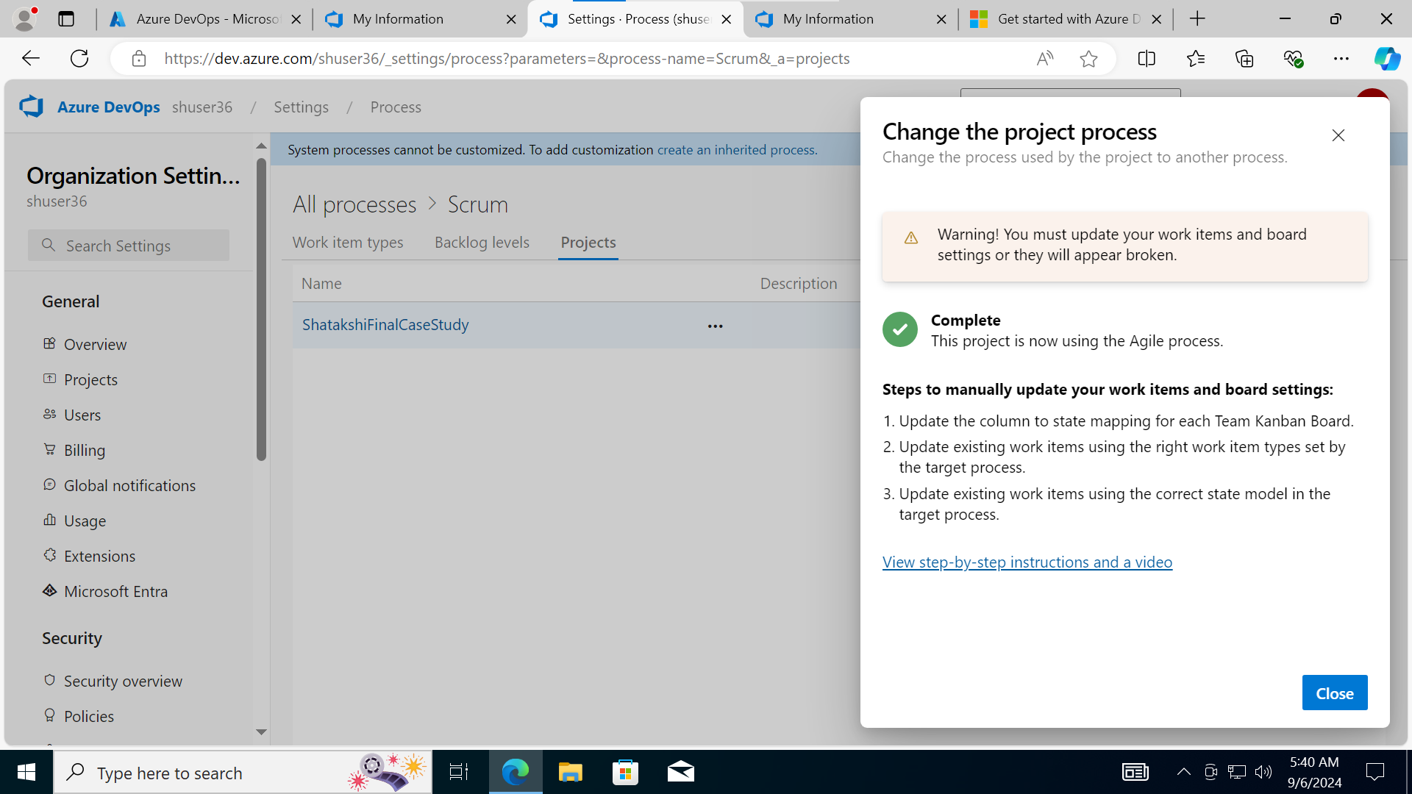

1. Create an Epic

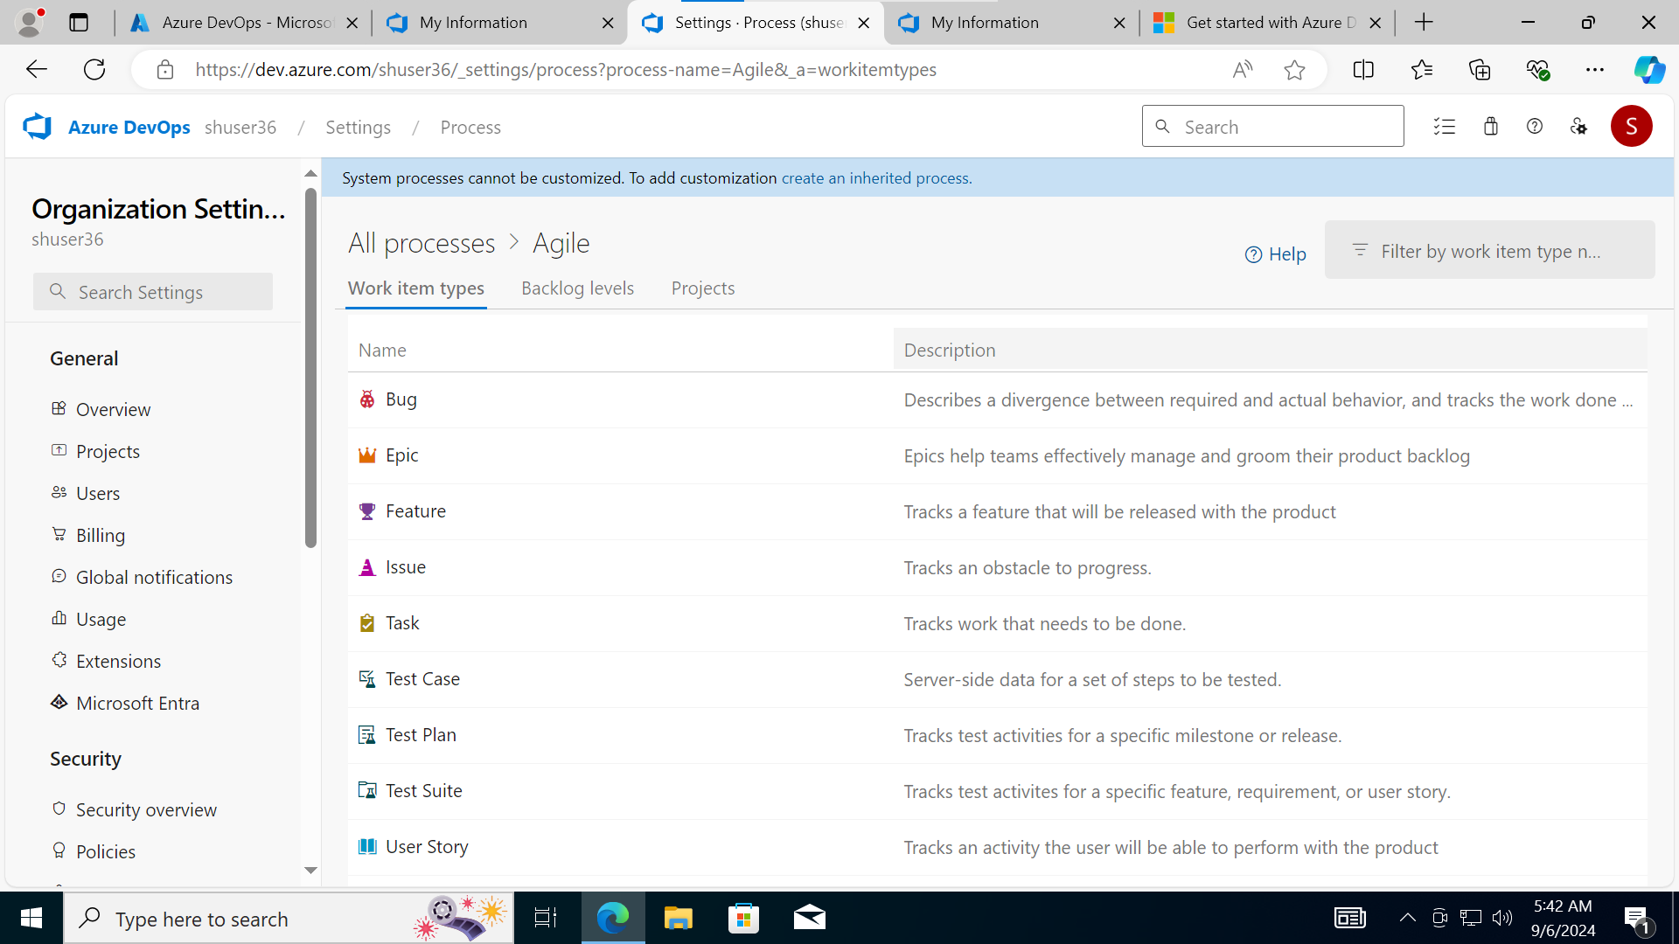

1. Create User story, Tasks, Subtasks, test case

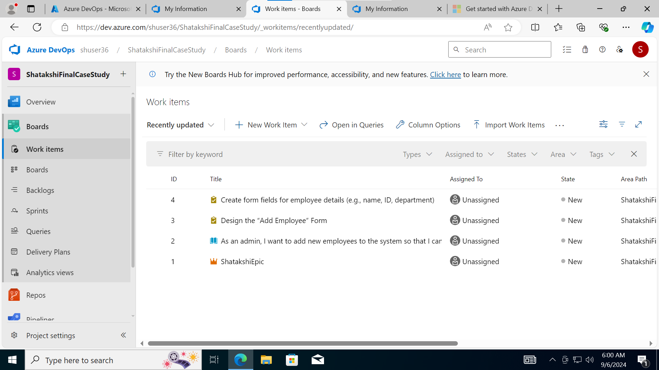

1. Link accordingly. User story->Task->sub task->test cases

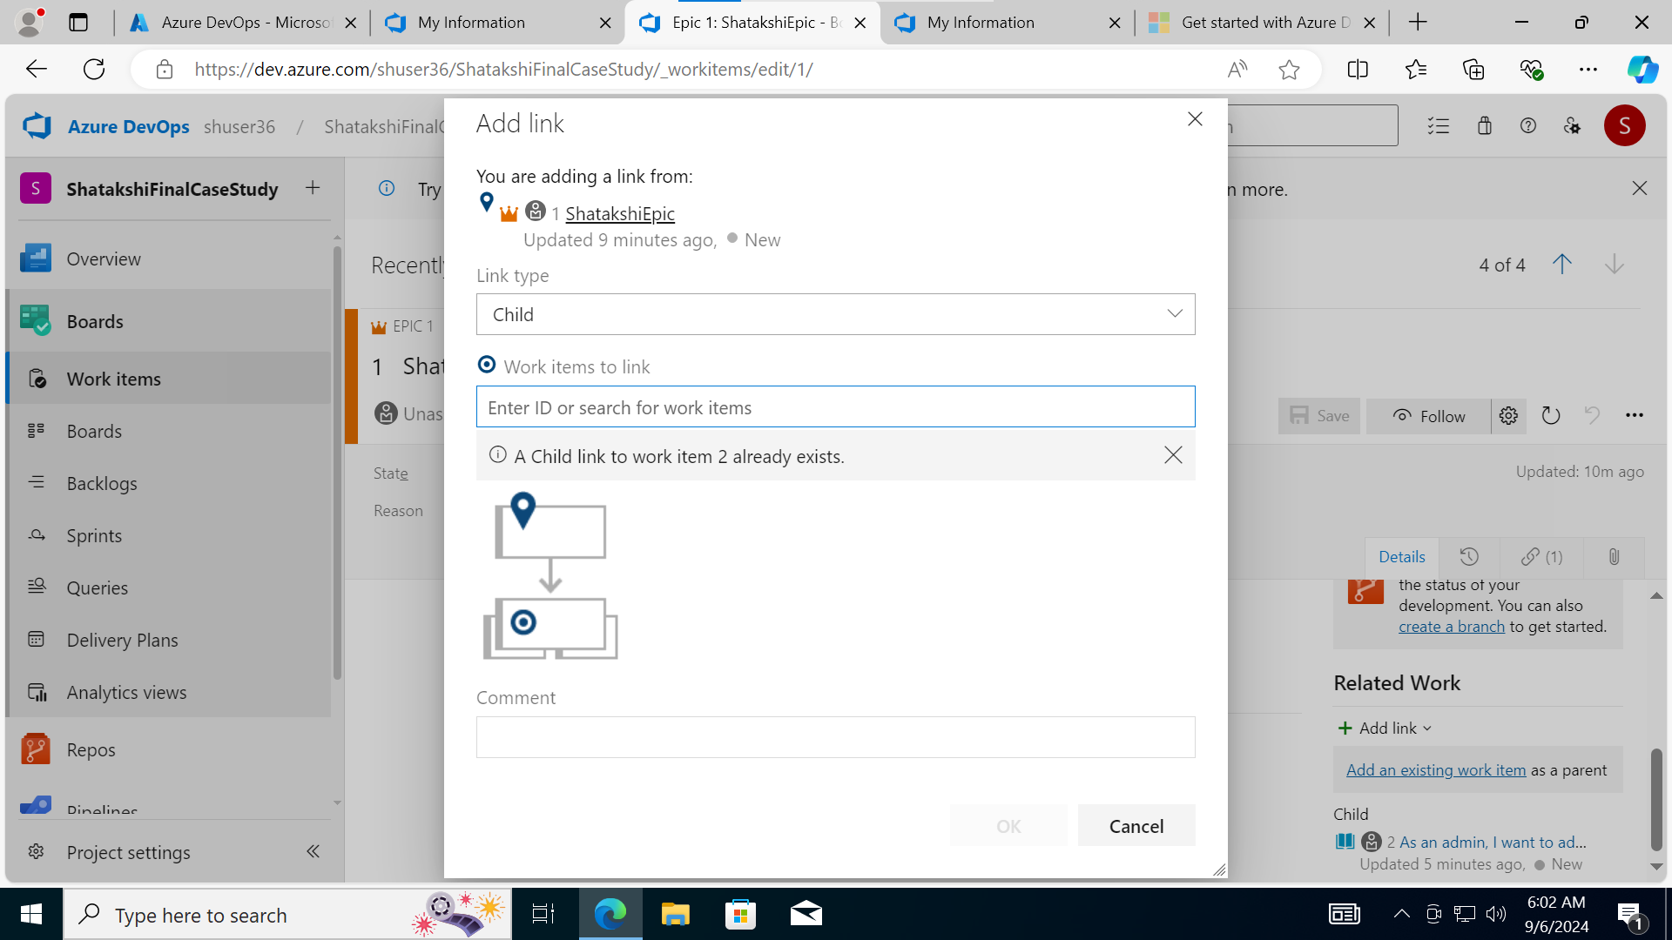

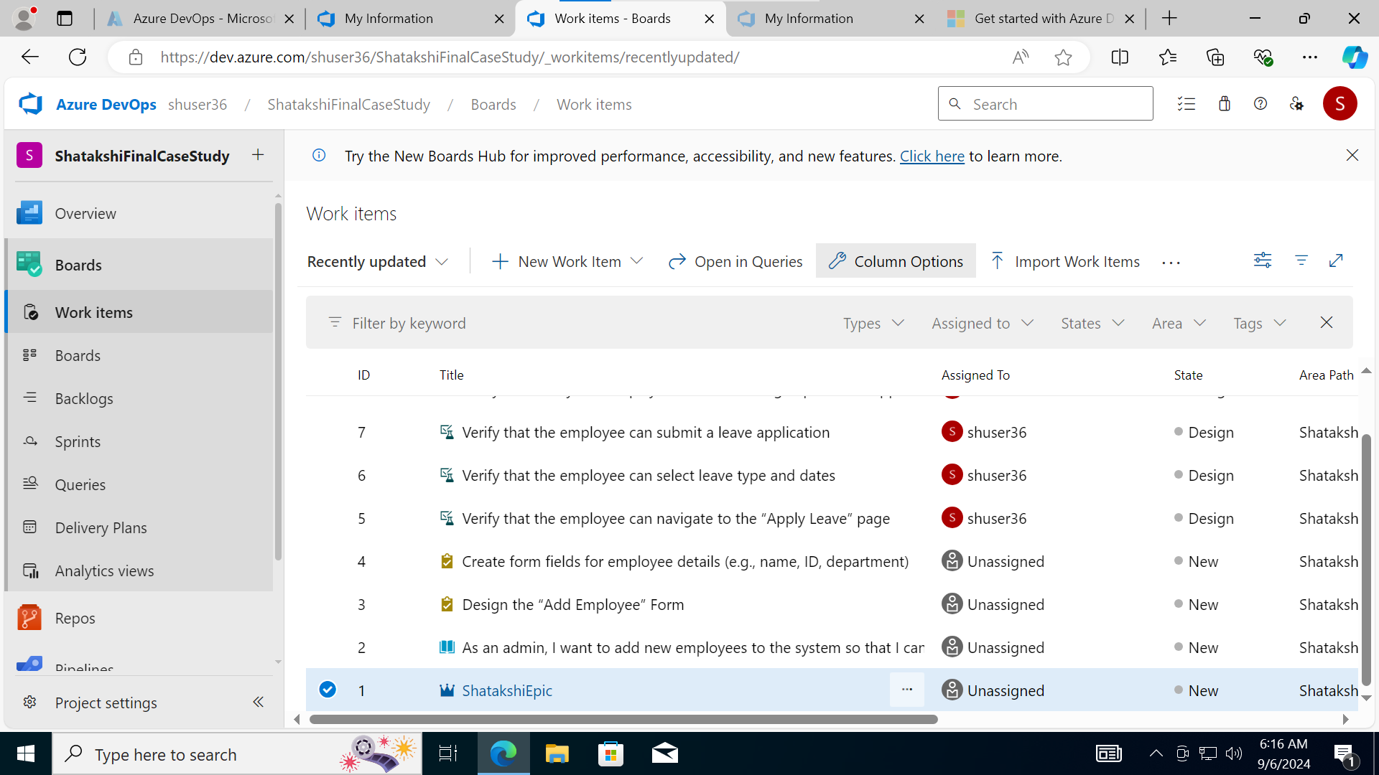

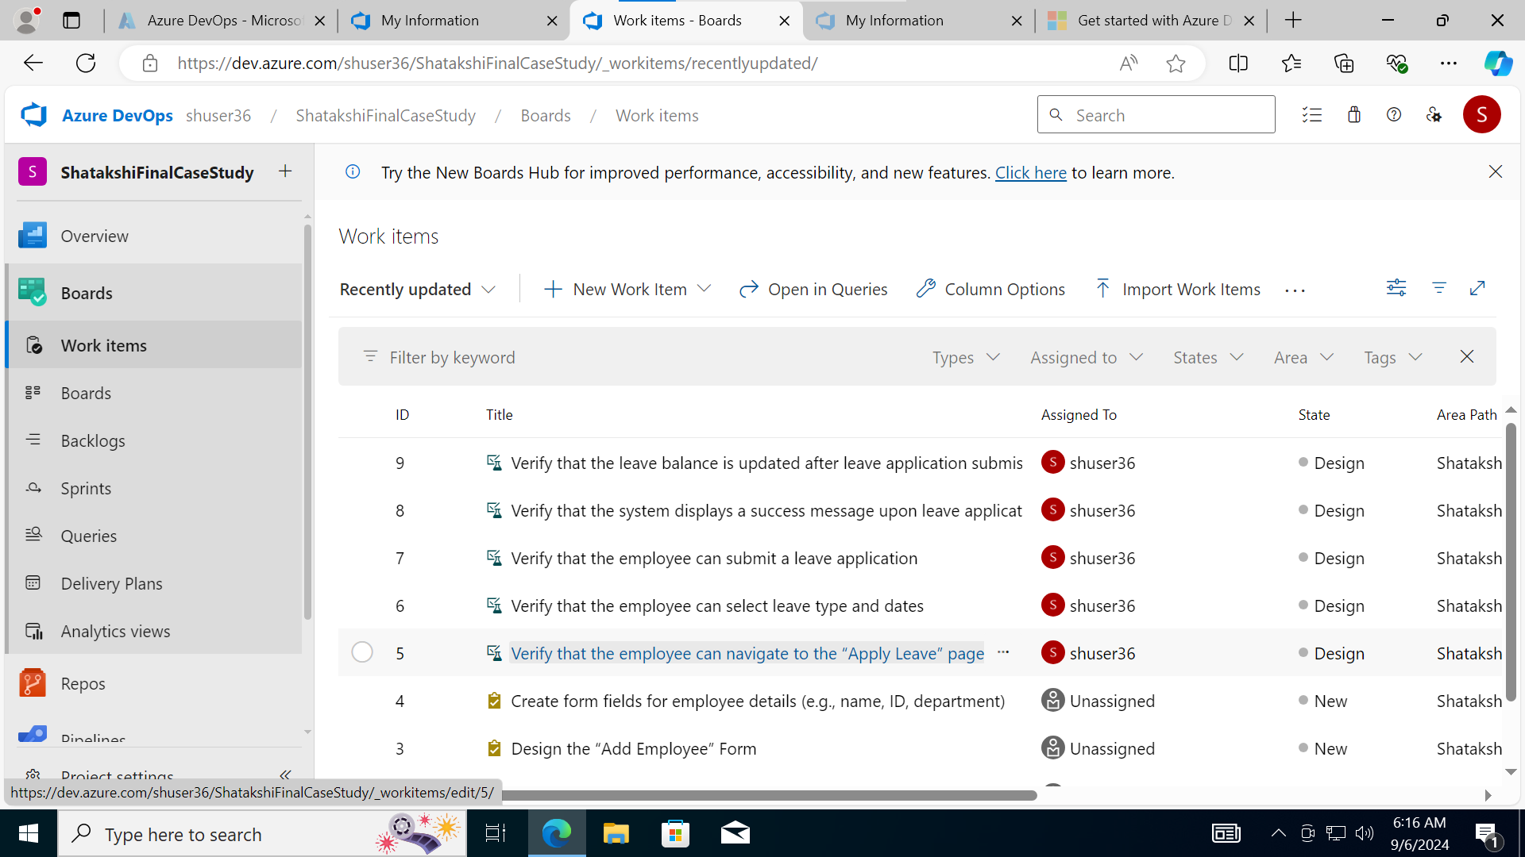

Linkages-

1. Epic

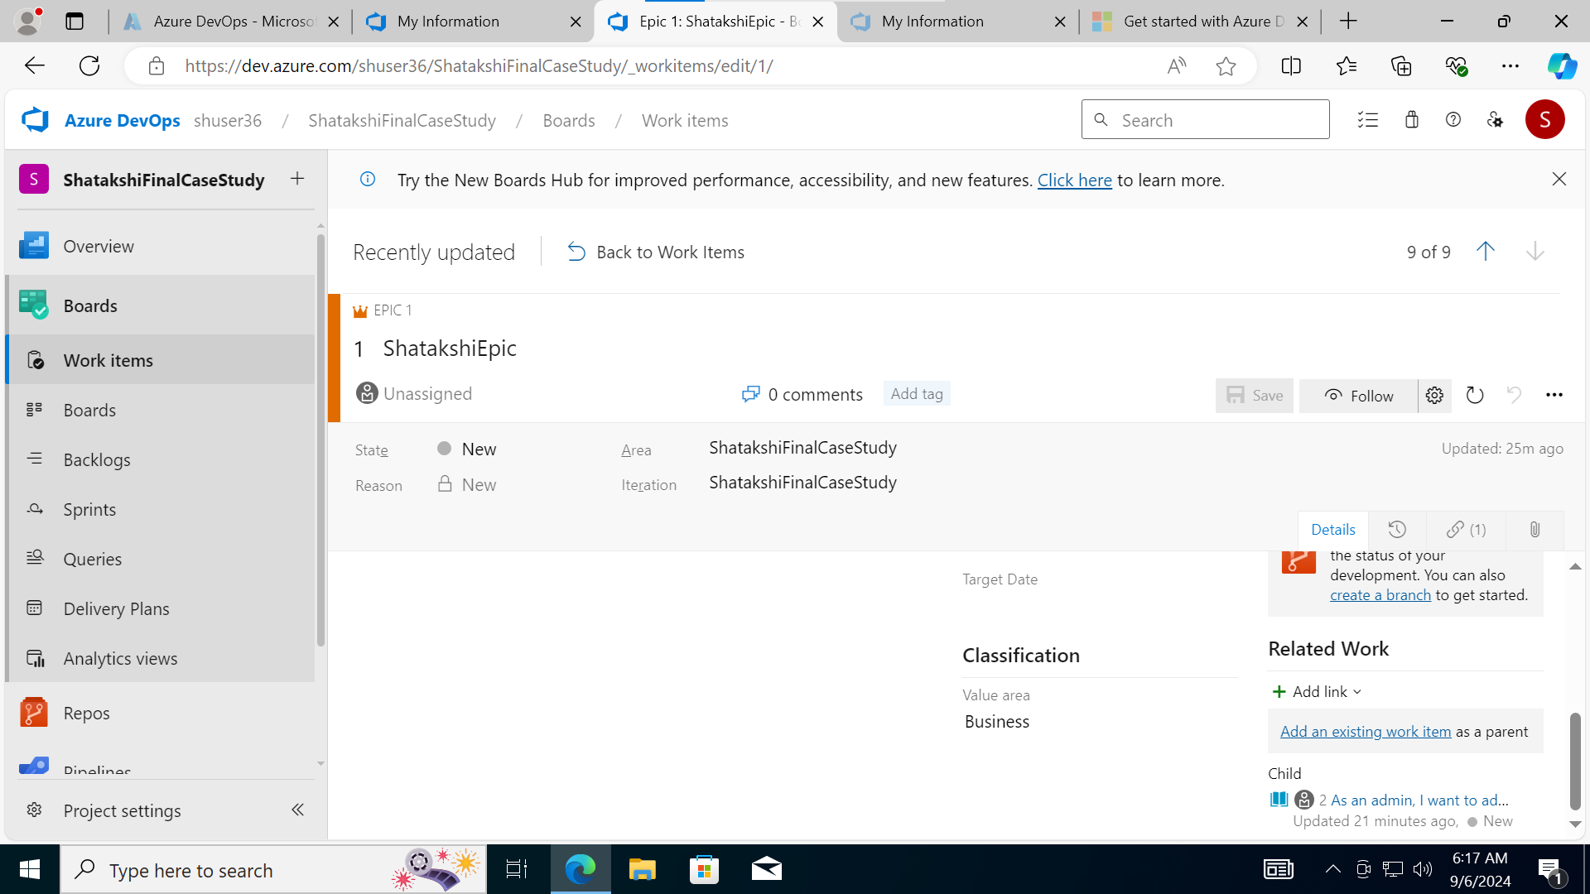

1. User Story

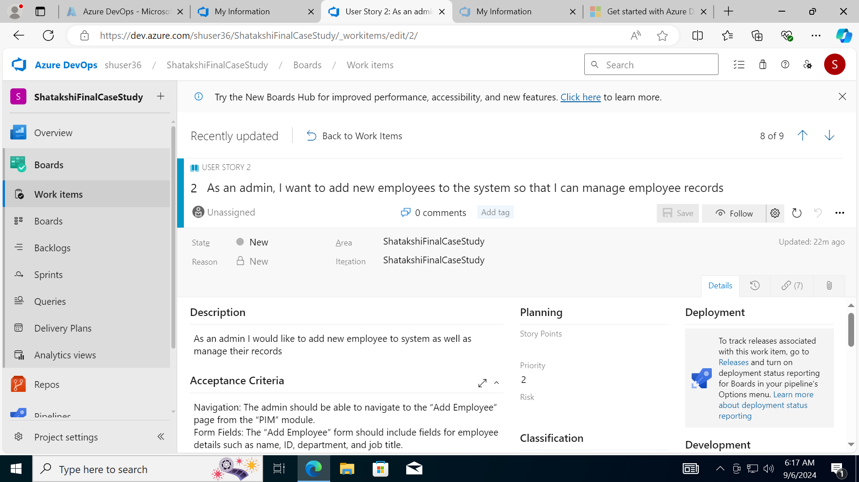

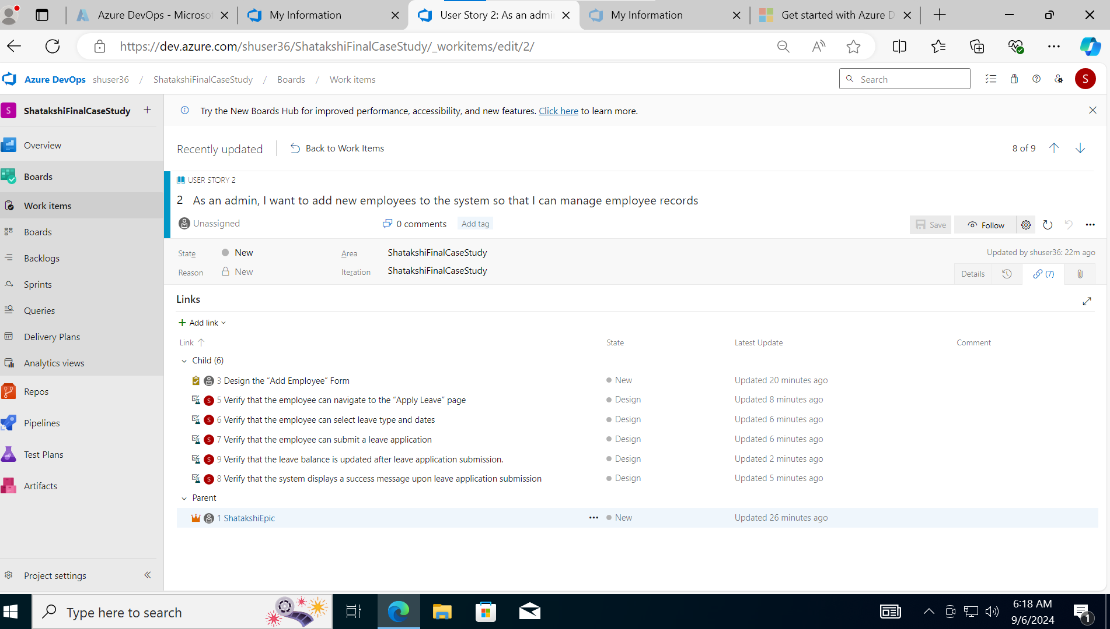

1. Task

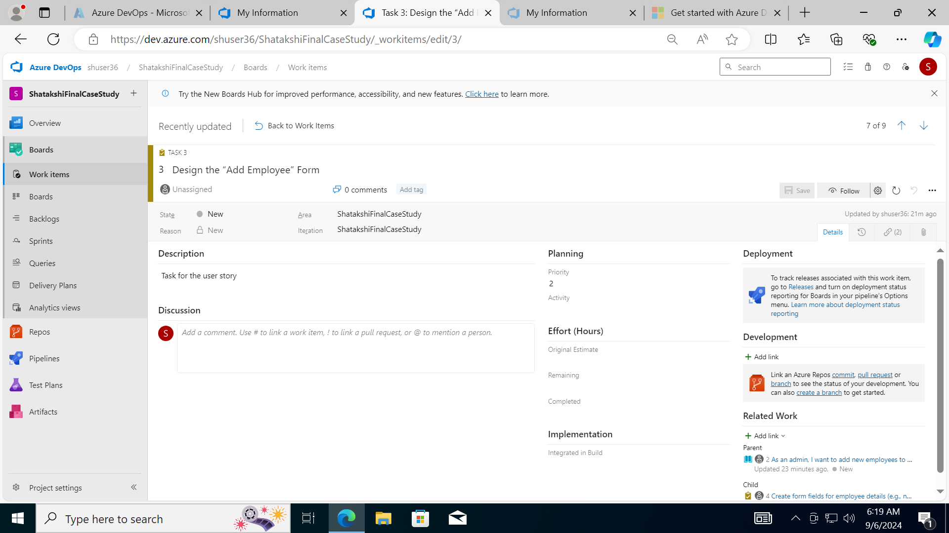

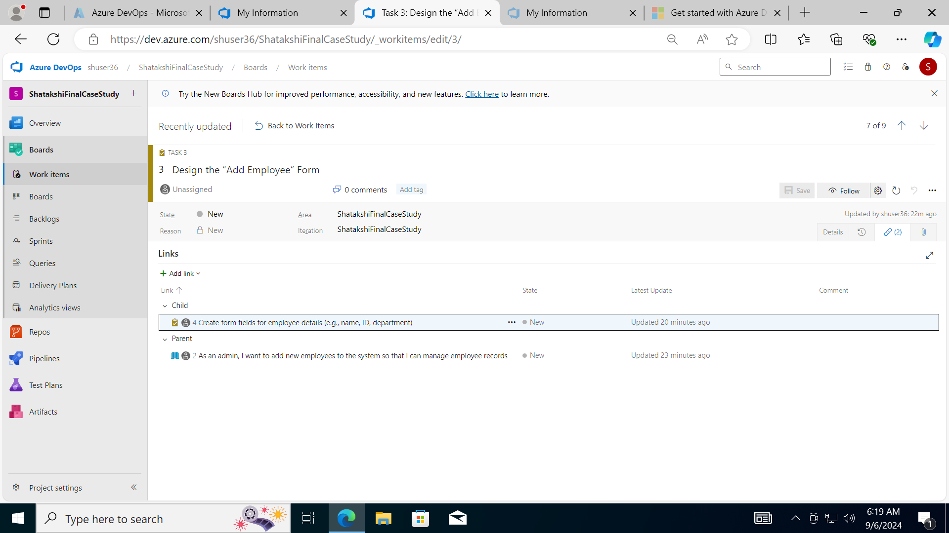

1. Subtasks

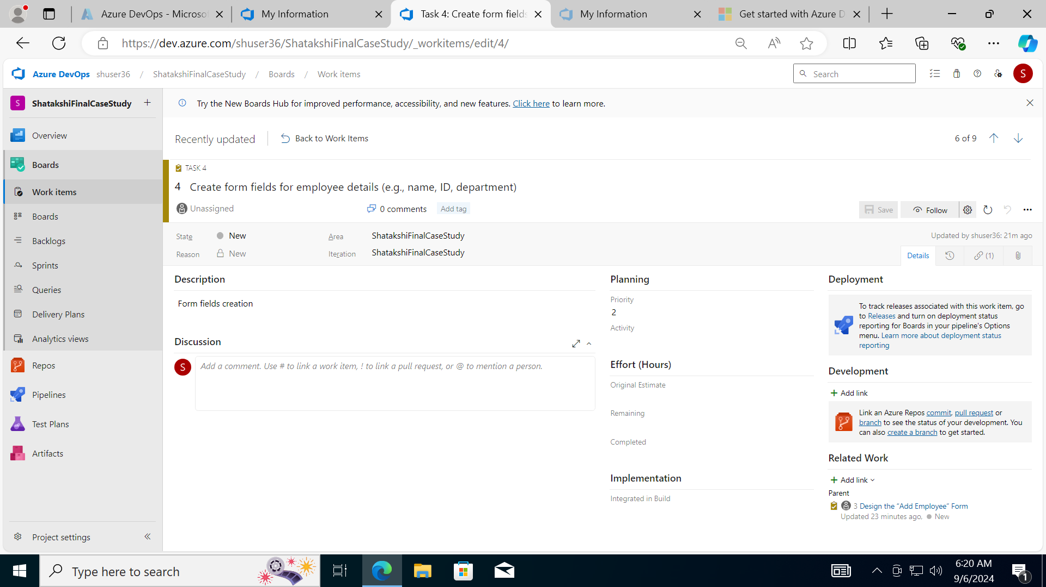

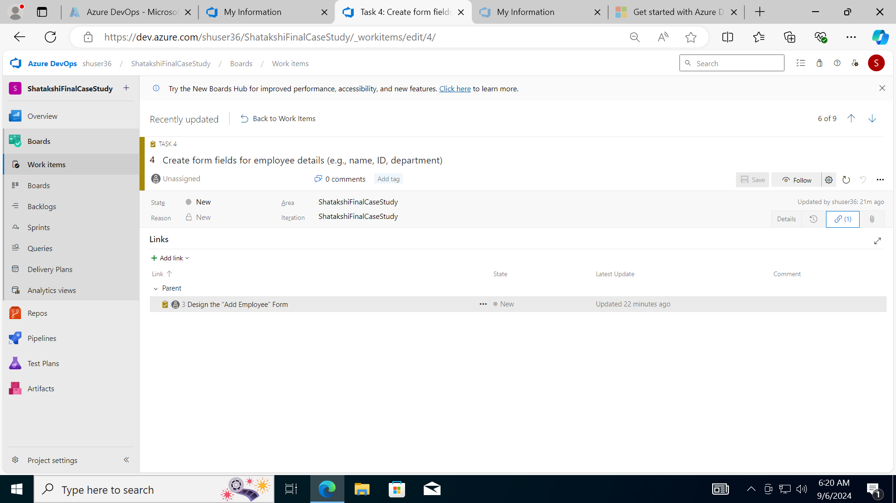

1. Test cases.

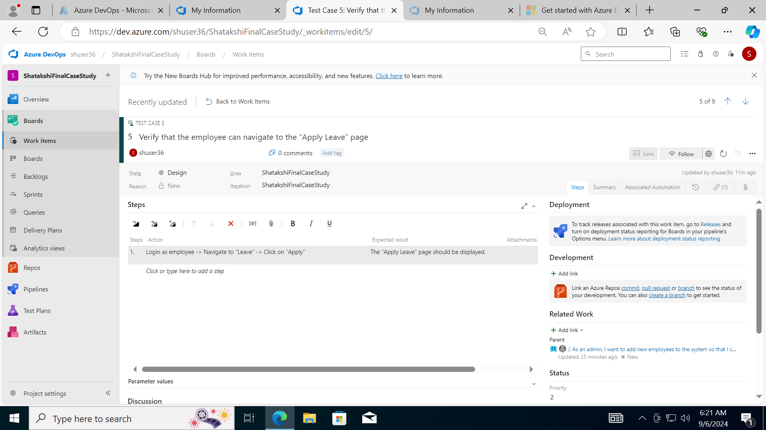

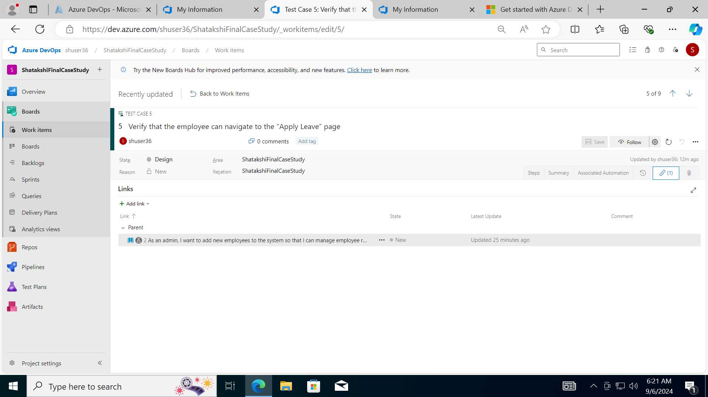

Similarly for other User stories

Execute All Test Cases Manually (Functional Testing)

Navigate to Test Plans: Go to “Test Plans” in Azure DevOps.

Create a New Test Plan: Click on “New Test Plan” and fill in the details.

Add Test Suites: Add test suites for each User Story.

Add Test Cases: Add the test cases you created to the respective test suites.

Execute Test Cases:

Open each test case and execute it manually.

Record the results (Pass/Fail) and any observations.

1. Adding a bug as a new work item

Navigate to the Failed Test Case:

In the test case execution view, if Test Case 3 fails, you will see an option to create a bug directly from the test case.

Create a Bug:

Click on the “Create bug” button. This is usually found in the test case execution view under the “Actions” menu or directly as a button when a test case fails.

Fill in Bug Details:

Title: Roles Not Assigned to User After Saving

Description: Provide a detailed description of the issue.

Steps to Reproduce: List the steps to reproduce the issue.

Expected Result: Describe what should happen.

Actual Result: Describe what actually happens.

Severity: Set the severity level of the bug (e.g., Major).

Priority: Set the priority level of the bug (e.g., High).

Attachments: Attach any relevant screenshots, logs, or files that can help in understanding and reproducing the issue.

Link the Bug to the Test Case and User Story:

In the bug form, scroll down to the “Related Work” section.

Click on “Add link” and select “Existing item”.

Choose “Test Case” and search for Test Case 3.

Select the test case and click “OK” to link it.

Similarly, link the bug to User Story 5 by choosing “User Story” and searching for User Story 5.

Save the Bug:

Once all the details are filled in, click “Save and Close” to create the bug.

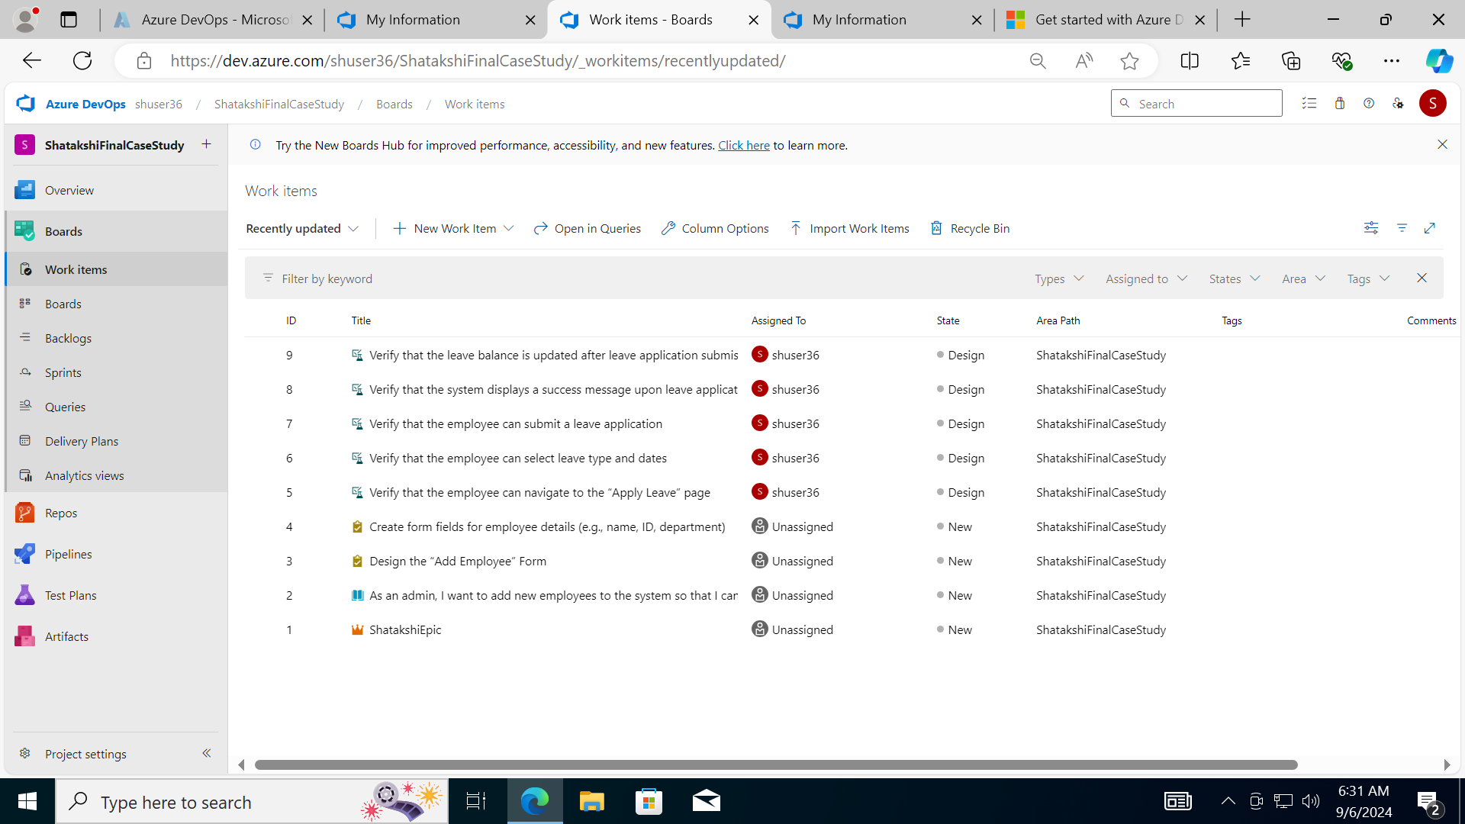

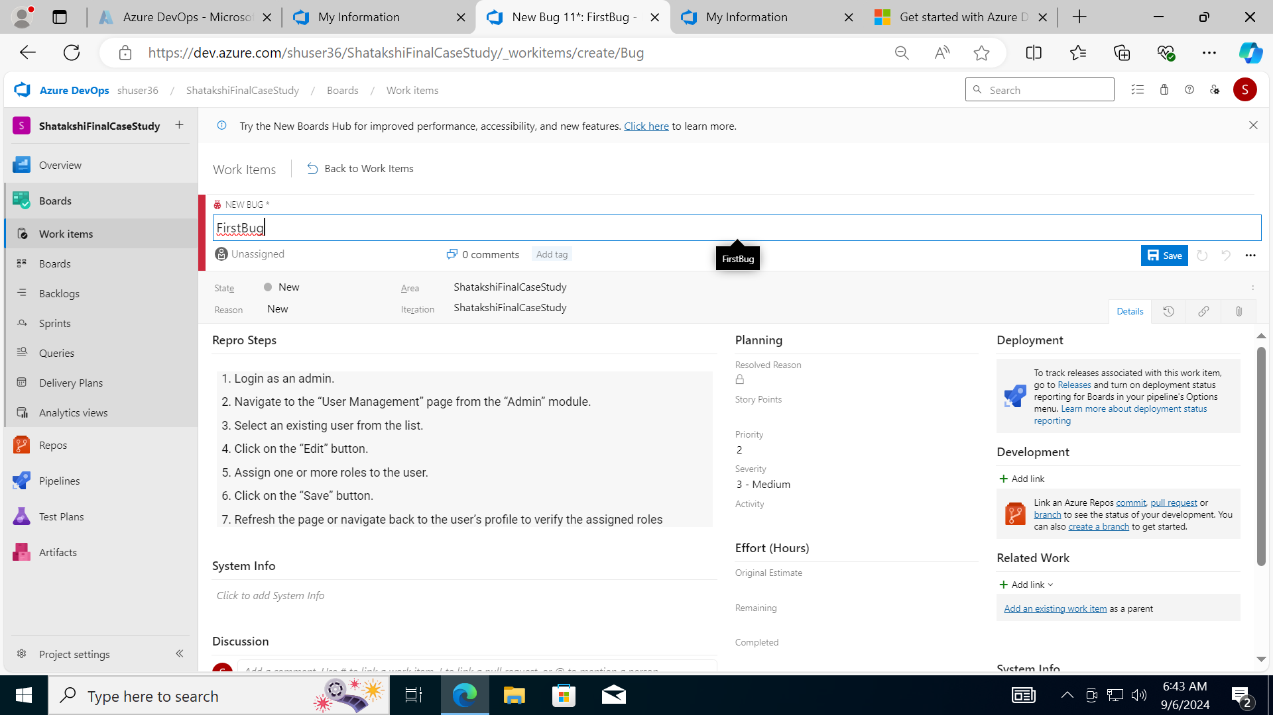

**Implementing the CI/CD Pipeline Using GitHub Actions**

1. Upload a code base into the repository

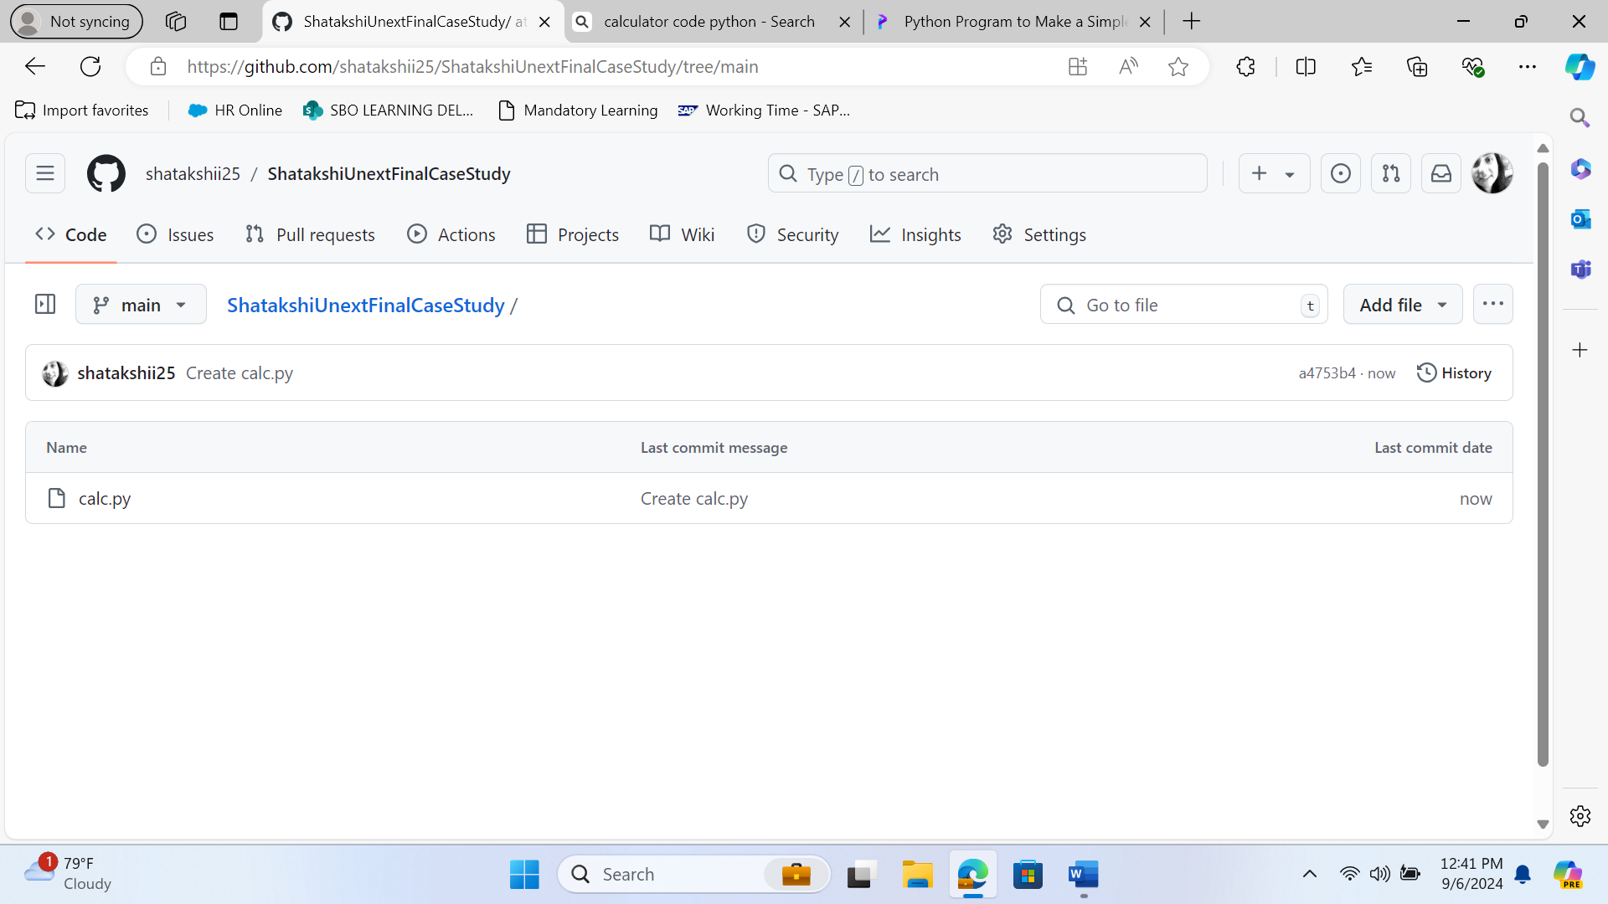

1. Creating new workflow on GitHub Actions

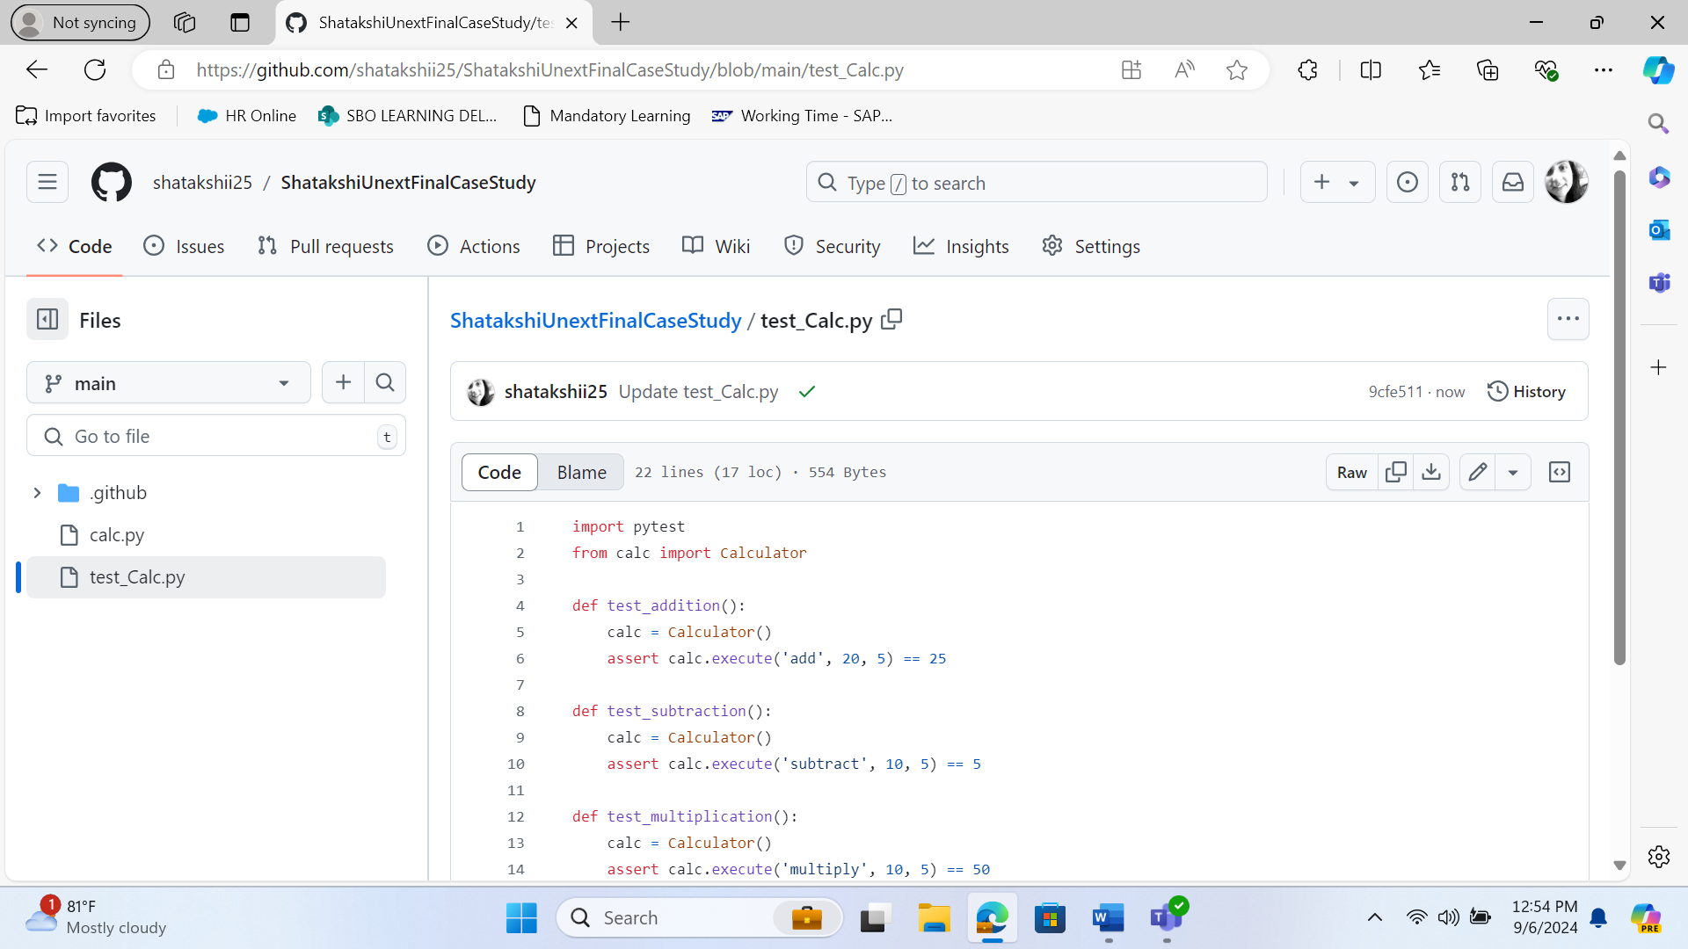

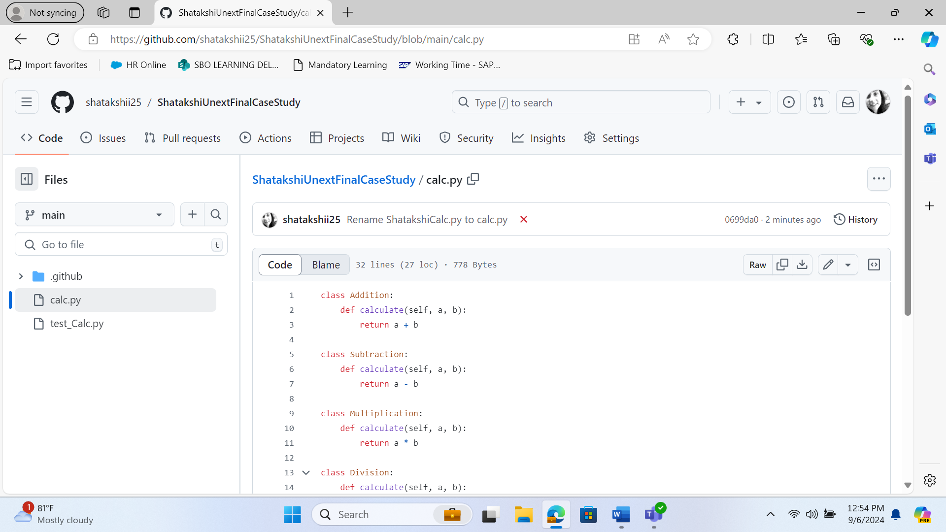

1. Monitor the created build
2. Modify the code to recheck the workflow and build

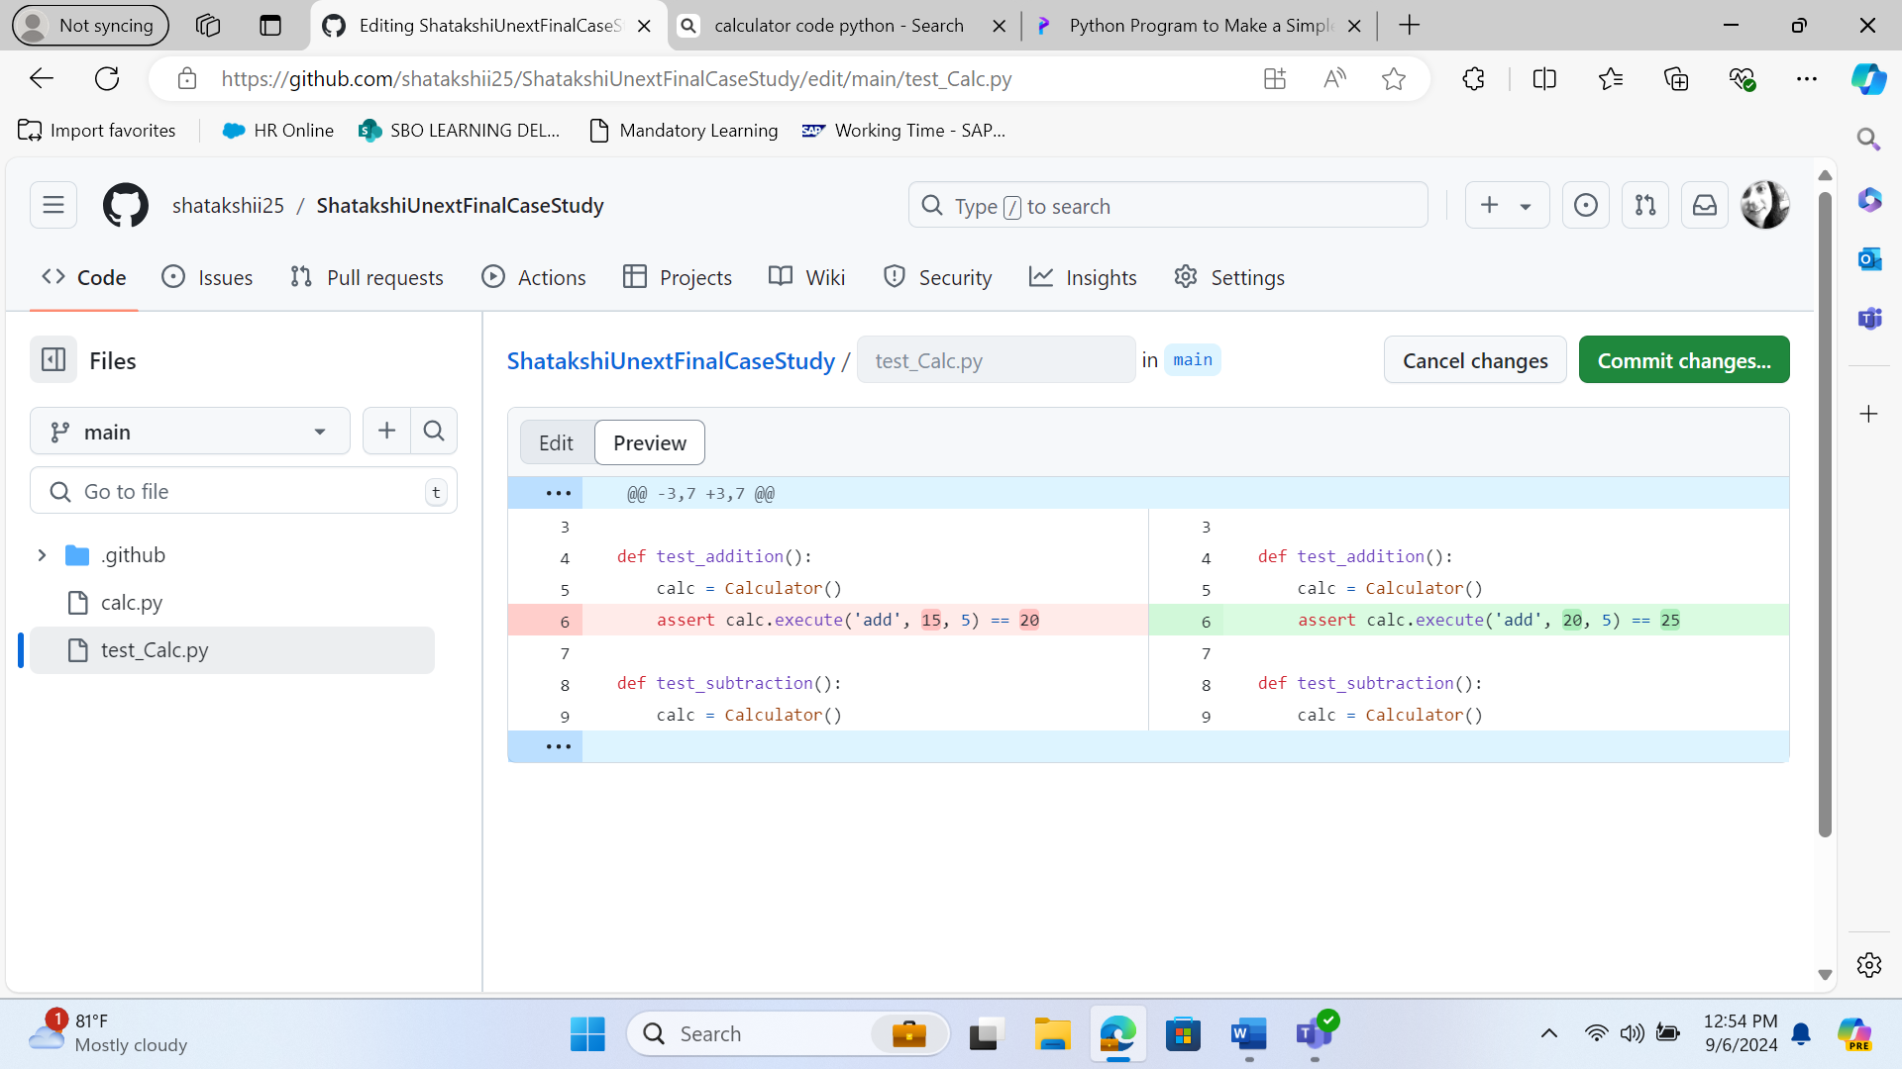

1. Commit and monitor the build result

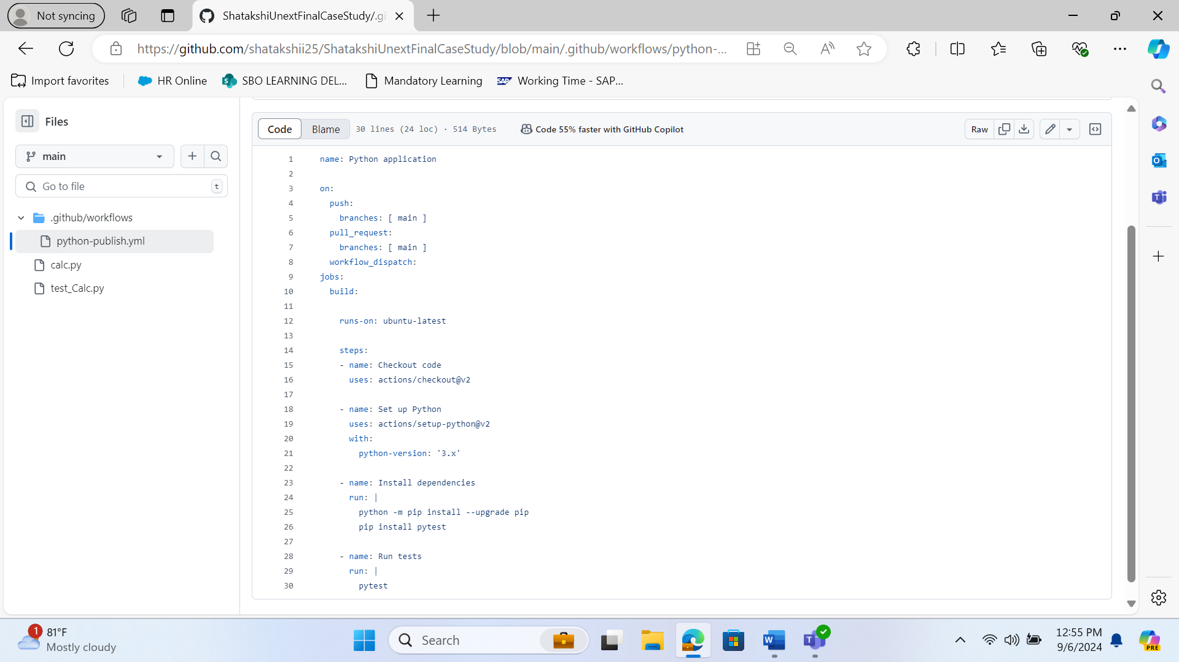

1. Adding test cases report and defect report

